Urban traffic optimisation
Design and simulation of a mathematical algorithm for adaptive traffic lights
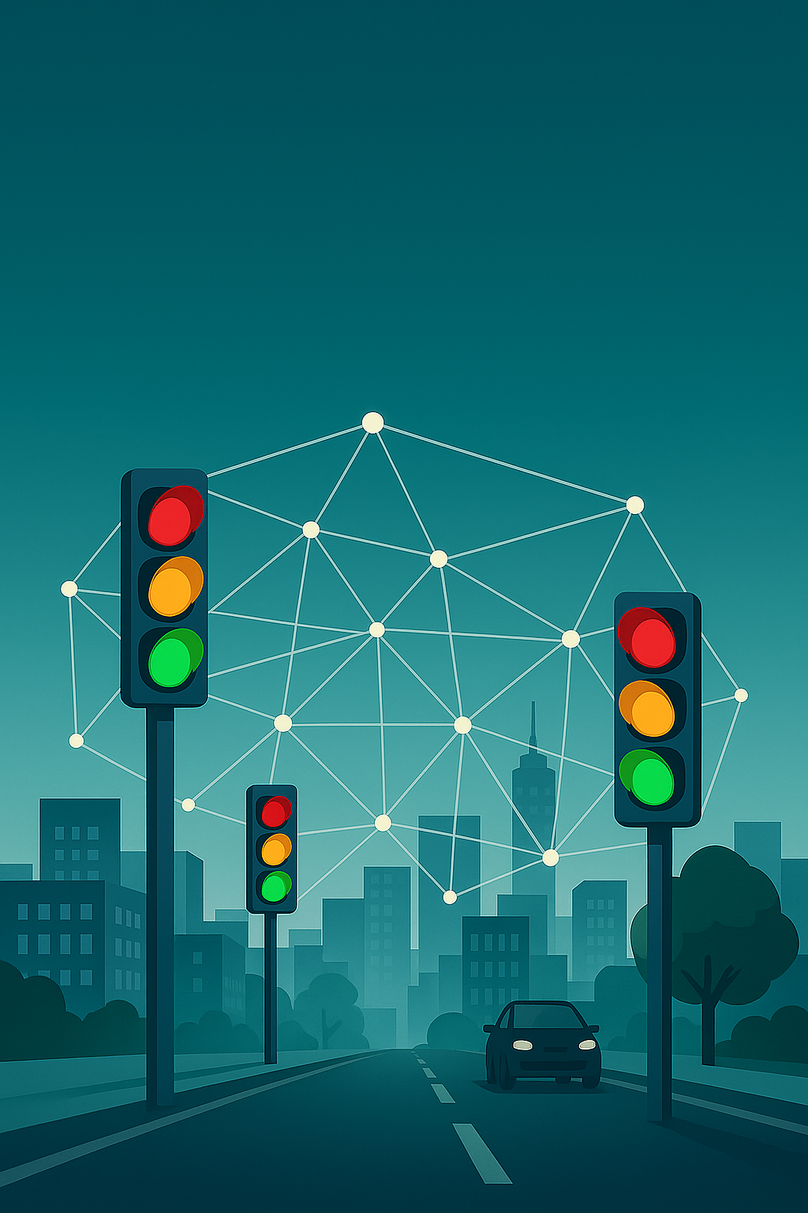
Author: Álvaro Ayas
Research project (Treball de Recerca), Batxillerat — Institut Numància
First prize, Premi Enginyer Pompeu Fabra 2026 — Escola d’Enginyeria, Universitat Pompeu Fabra
English edition, revised September 2026

“Essentially, all models are wrong, but some are useful.”
— George E. P. Box

Acknowledgements
I would like to thank everyone who has accompanied me during the preparation of this research project and who, in one way or another, has made it possible.
First of all, I want to thank my tutor, Néstor Martínez, for his dedication, patience and guidance throughout the whole process. His support was key to steering and developing this project with rigour and motivation.
Secondly, I would like to thank my mother for her help in assessing different sections and points of the work.
I would also like to thank the teachers involved for their availability and interest, and for the advice and contributions that have enriched the work and helped me grow academically.
To the rest of my family, thank you for your unconditional support, for believing in me at every moment and for always being by my side, in good times and in the more difficult ones.
And finally, to my friends, for always being there, for encouraging me, listening to me and helping me disconnect when I needed it most.
To all of you, thank you with all my heart.

Abstract
This project explores the adaptive optimisation of urban traffic lights through a mathematical and computational approach. Its aim is to design an algorithm that decides, second by second, which phase of a traffic light should be active, according to the number of vehicles and pedestrians waiting, and to compare it objectively with the traffic lights used today.
Using concepts from queueing theory, a phase-pressure function is formulated: the vehicle term is the time needed to clear each queue, N/(μ − λ), and the pedestrian term grows with the number of people waiting and with the waiting time of the person who has waited longest, with an extra penalty that prevents anyone from waiting indefinitely. The controller always activates the phase with the highest pressure, respecting minimum and maximum green times and safe transitions.
The algorithm was implemented in the SUMO traffic simulator and compared with a fixed-time plan designed with Webster’s method and with SUMO’s actuated controller, in a simple mid-block pedestrian crossing and in a four-arm “Shibuya-type” intersection, over a range of demand levels and with repeated simulations. Each case was simulated with 20 random seeds. The results are more nuanced than the 80 % improvement reported in the first version of this project, which was caused by errors in the code. In the simple crossing, the adaptive controller gives vehicles practically the same delay as the Webster plan (+1 to +5 %) while cutting pedestrian waiting by 28–42 %. In the collapsed Shibuya-type intersection it reduces vehicle delay by 10 % and increases throughput by 28 %, but at intermediate demand the fixed-time plan remains better. The adaptive controller outperforms SUMO’s actuated controller in almost every case. The hypothesis is therefore only partially confirmed: adaptive control helps most when the intersection is saturated or the demand is unbalanced, and a well-designed fixed-time plan is a strong competitor otherwise.
Keywords: urban traffic, adaptive traffic lights, optimisation, queueing theory, SUMO, mathematical model.

Contents
1. Introduction 6
2. Objectives and hypothesis 7
3. Analysis of current traffic 8
3.1 How traffic works 8
3.2 Common urban traffic problems in Barcelona 9
3.3 Factors that determine traffic flow in Barcelona 10
4. Study of conventional traffic lights 16
4.1 Fixed-time traffic lights 16
4.2 Actuated traffic lights 17
5. Adaptive traffic lights as a solution 19
5.1 Proposed models 19
6. Mathematical model of the adaptive control system 20
6.1 State space and definition of variables 20
6.2 Definition of the dynamic prioritisation functional 20
6.3 Control policy 22
6.4 Interpretation in terms of optimisation 23
6.5 Theoretical properties of the model 23
6.6 Limitations of the model 24
7. Simulation of the adaptive traffic lights 25
7.1 Creation of the digital environment 25
7.2 Measuring the saturation flow μ 27
7.3 Implementation of the adaptive controller 27
7.4 Reference controllers 28
7.5 Calibration of the controller parameters 29
8. Results and analysis 31
8.1 Methodology and evaluation metrics 31
8.2 Simple intersection: two-way road with a pedestrian crossing 32
8.3 Shibuya-type intersection 34
8.4 Shibuya-type intersection with unbalanced demand 36
8.5 Emissions and the question of Barcelona 37
8.6 Comparison with the results of the original version 38
8.7 Conclusions of the comparative study 38
9. Possible future improvements 40
9.1 Integration of artificial intelligence (AI) 40
9.2 Expansion to networks with several types of intersection 41
10. Visit to the Mobility Management Centre (Barcelona) 42
11. Conclusions 44
Bibliography 45
Annexes 47
Declaration on the use of generative AI tools 48

1. Introduction
Ever since I was little, mathematics has been my favourite subject. I have always liked it because it makes sense: it follows a clear logic, with reasoning behind it that guides you to understand how the world works. That is why I decided to focus my research project on this discipline.
At first I did not know what topic to choose, and many possible ideas came to mind: the analysis of the ideal punch using mathematics, mathematics in music, the analysis and algorithms of the natural evolution of a population of individuals… I found all of them interesting, but none fully convinced me.
It was then that my tutor suggested a topic: trying to build a traffic optimisation algorithm in order to create adaptive traffic lights that would make traffic flow more smoothly. The topic caught my attention from the first moment, and I decided there and then that it would be the subject of my research project.
I chose this topic because I believe that traffic networks are, in many cases, a real problem today: they are often very slow and harm not only drivers but also pedestrians. The fact that automatic traffic lights, which change from green to red every “t” units of time without taking any variable into account (such as the number of vehicles and pedestrians), still govern traffic may be one of the main reasons for its poor optimisation and efficiency. For this reason, I set out to create an algorithm for adaptive traffic lights that change from green to red not only every “t” units of time, but also taking into account those other variables.
Besides this, I also decided to dive into this topic because I thought it could be very useful for learning how artificial intelligence (AI) works, its real-world applications and how it can act as an assistant when preparing a piece of work, as well as because of my interest in programming, which has led me to obtain Python programming certificates. In addition, this project is linked to the Sustainable Development Goals (SDGs), especially SDG 11 (Sustainable cities and communities), since it seeks to improve urban mobility and reduce traffic congestion, and SDG 13 (Climate action), since optimising traffic can help reduce polluting emissions.
The points I set out to address in this project are the following:
1. Analysis and study of the current traffic situation and of conventional traffic light systems.
2. Development of a mathematical model for the adaptive optimisation of traffic lights.
3. Development of a traffic simulator using SUMO (Simulation of Urban MObility), on which to implement the algorithm.
The project has a theoretical part and a practical part. The theoretical part (chapters 3 and 4) explains and analyses the current traffic situation and conventional traffic light systems, as well as their applications today. The practical part (chapters 5 to 10) is devoted to the development of the mathematical model for adaptive traffic lights and its implementation in a traffic simulator. For this, the SUMO software is used, which makes it possible to create realistic urban simulation environments in which to assess how the algorithm works and evaluate its efficiency, comparing it with systems that use conventional traffic lights.
This plan makes it possible not only to test the theoretical feasibility of the algorithm but also to obtain practical results with which to assess the possible improvement in traffic efficiency. It should be stressed that the main goal of the project is the development of the optimisation model for adaptive traffic lights. Although the results are analysed, the main purpose of that analysis is to validate how the model works.

2. Objectives and hypothesis
Before starting the study, it is necessary to clarify exactly what its objectives are and the hypothesis on which it is based.
The general objective of this project is to design and evaluate an adaptive traffic signal control system capable of optimising urban traffic flow and reducing congestion compared with traditional traffic light systems.
From this general objective, the following specific objectives are set:
1. Develop an optimisation algorithm capable of adapting signal timings to the simulated traffic conditions.
2. Implement, in a simulation environment (SUMO), a signalised intersection under different control schemes: fixed-time control, actuated control and adaptive control following the developed algorithm.
3. Compare the performance of the different systems using objective metrics: mean delay, waiting times, throughput and estimated emissions, among others specified later in the project.
4. Assess possible applications and limitations of the system in a real urban context.
From this approach, the following main hypothesis is derived:
Hypothesis
An adaptive traffic light system based on a mathematical optimisation model will reduce the mean delay of the vehicles in the queues compared with conventional fixed-time systems.

3. Analysis of current traffic
Urban traffic is a fundamental element to consider in the functioning and layout of cities. Its correct, or incorrect, management directly affects citizens’ quality of life, road safety, the environment and the local economy, among other factors. Today, many urban areas suffer from problems derived from poor traffic management, which create flow problems that translate into congestion, delays, polluting emissions and a higher risk of accidents for both vehicles and pedestrians.
It is therefore necessary to analyse in detail how traffic works today, identify the factors that affect its efficiency and understand the most common problems. This knowledge is essential in order to propose innovative alternatives, such as adaptive traffic lights, that adjust to real needs at every moment. To carry out this study with real data, and considering that each urban environment is unique, I will focus the analysis on the city of Barcelona, the largest urban centre in Catalonia.
The following sections address key aspects of urban traffic: how it works, the usual problems it presents and the factors that determine how smoothly it flows.

3.1 How traffic works
Urban traffic is the result of the interaction between vehicles and pedestrians sharing the same road network. Its organisation responds to the need to ensure, in principle, efficient and safe mobility in an environment with a variable population, where the number of journeys can vary greatly.

3.1.1 Road infrastructure
Road infrastructure is the skeleton on which mobility takes place. It consists of different parts. The main ones are:
- Pavements (sidewalks): generally narrow ways intended for pedestrian traffic and, in certain circumstances, for vehicles travelling at reduced speed. They are characterised by high pedestrian traffic.
- Roads (or streets): wider ways intended mainly for vehicle traffic, with less interference from pedestrians. They usually have two pavements, one on each side, connected at certain points by pedestrian crossings.
- Avenues: wide streets with several lanes in each direction, designed to absorb a high traffic flow and allow fast journeys within the city. They often have green areas and wide pavements.
- Intersections: points where two or more ways cross, whether streets or pavements. They are often regulated by traffic lights or traffic signs, and they are a critical element of traffic control; their correct management is key to ensuring that traffic works properly.

3.1.2 Traffic regulations and signs
Traffic is always governed by a set of regulations and signs that guarantee that it works properly, in an orderly and safe way. Regulations establish rules of conduct for vehicles, while signs manage specific situations and inform drivers that a special rule applies in that area. Some examples of traffic signs are:
- Traffic lights: control devices that regulate the passage of vehicles and pedestrians at certain intersections of the road network. Their main purpose is to guarantee safety and optimise traffic flow by alternating the right of way with coloured lights: green, amber and red. Green allows passage, amber warns of an imminent change and red requires stopping.
- STOP signs: control signs found at certain vehicle intersections. They work similarly to traffic lights, except that they normally only operate at simple street-to-street intersections. Their main purpose is to guarantee safety and an optimal traffic flow.

3.2 Common urban traffic problems in Barcelona
Barcelona is one of the European cities with the highest traffic density, especially during rush hours. According to Barcelona City Council’s Peak-Hour Traffic Congestion Index, during the busiest hours traffic in the city can reach congestion levels, with an average of 3.9 out of 5, where 5 indicates extreme congestion.
The consequences are significant: according to the TomTom Traffic Index, drivers in Barcelona lose 87 hours a year stuck in traffic jams, placing the city at the top of Spain for time lost to congestion. The problem is even more serious at the metropolitan access roads, where it is estimated that 63,000 hours are lost in tailbacks every working day, the equivalent of 15.3 million hours a year, generating, among other things, an economic cost of more than €650,000 per day.
Public perception confirms this: a RACC survey reveals that 8 out of 10 drivers believe congestion has worsened in recent years, and that this affects road safety and quality of life in the city.
It is also essential to point out that congestion is not only a problem of time and efficiency, but also of the environment and public health. Traffic in Barcelona is responsible for 54 % of nitrogen oxide (NOx) emissions and 40 % of suspended particles in the city. These emissions represent a health problem, increasing the risk of various respiratory and cardiovascular diseases, and add to the social costs associated with mobility.
For all these reasons, implementing more efficient traffic regulation systems is key to making traffic in Barcelona more efficient in terms of time and economy, and to reducing its environmental impact and the medical consequences it can have for citizens. To implement these more efficient mechanisms, it is vital to analyse the factors that determine how smoothly traffic flows in Barcelona, since these are responsible for the problems mentioned above.
Table 1: Summary of the problems derived from traffic inefficiency in Barcelona (the original Figure 1).
Magnitude | Value
Average time lost (hours / year / driver) | 87
Hours lost at metropolitan access roads (hours / year) | 15,300,000
Derived economic cost (€ / day) | 650,000
Share of the city’s NOx emissions due to road traffic (all traffic, not only congestion) | 54 %
Share of the city’s suspended particle emissions due to road traffic | 40 %

3.3 Factors that determine traffic flow in Barcelona
Traffic flow in Barcelona is influenced by a combination of structural, operational and behavioural factors that together determine the level of congestion and the efficiency of the road system. The correct functioning of these factors is key to achieving a Barcelona with smoother traffic.

3.3.1 Structural factors
The physical structure of the city of Barcelona plays a fundamental role in the efficiency of traffic. Both geographical and urban-planning factors are analysed below.

3.3.1.1 Geographical factors
It makes sense to start with geography, since it plays an essential role. The city of Barcelona lies on a narrow plain bounded by the Mediterranean Sea to the east and the Collserola range to the west.
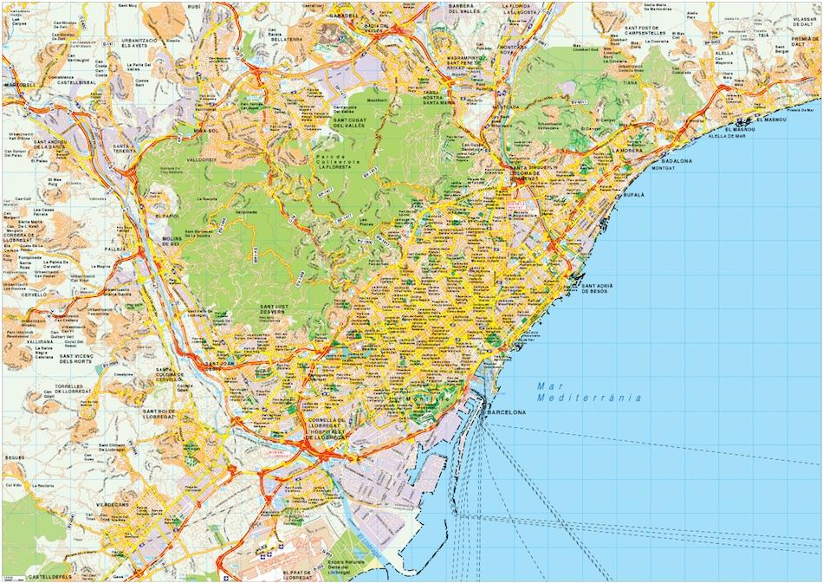
Figure 1: Map of Barcelona (plan view).
This geographical configuration, combining sea and mountains, severely conditions mobility and urban growth. In particular, two of the ring roads that should allow fast journeys, the Ronda de Dalt and the Ronda Litoral, are directly conditioned by it. The Ronda de Dalt often becomes saturated, causing delays and congestion. However, neither widening it with more lanes nor building another, more peripheral ring road are viable solutions, since the Collserola range acts as a natural barrier and tunnelling through the mountain is not a realistic option. The same applies to the Ronda Litoral, which also suffers frequent tailbacks and has the Mediterranean Sea as its geographical limit.
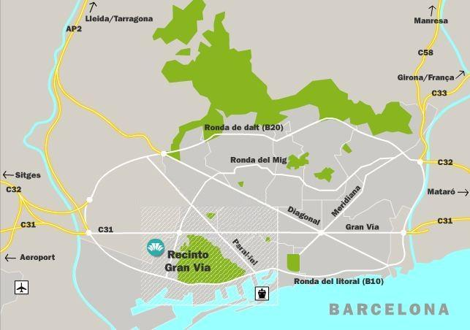
Figure 2: Main roads of Barcelona, showing the geographical limits to the north and south.
By contrast, and to understand what this means through a comparison, the other large urban centre in Spain, Madrid, presents a very different situation: located on the Central Plateau and surrounded mostly by large expanses of flat land, it has much greater freedom for urban and road expansion. This has made it possible to develop a radial road network that connects the city centre with the periphery more directly.
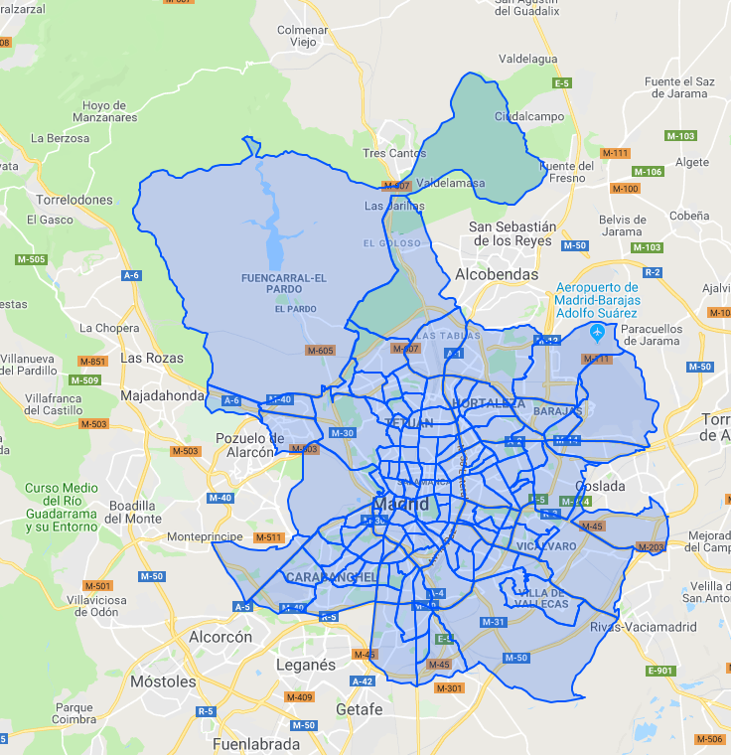
Figure 3: Map of Madrid (plan view).
We can clearly see how the road network of the Spanish capital is more concentrated in the east and south-west, where there is no geographical obstacle and the network can expand. In the north-west, the El Pardo hills physically prevent road development in the same way as flat areas do, and the concentration of roads there is much lower. We can conclude that having flat land available to expand the road network is key to developing an optimal network, something Barcelona lacks.
The differences in traffic flow between Madrid and Barcelona further show the importance of having land available to expand the road network:
- In Barcelona, drivers lose an average of 87 hours a year in traffic jams, which translates into an average of 31 minutes and 13 seconds to travel 10 km.
- In Madrid, by contrast, drivers lose an average of 64 hours a year in traffic jams, and it takes an average of 24 minutes and 44 seconds to travel 10 km.
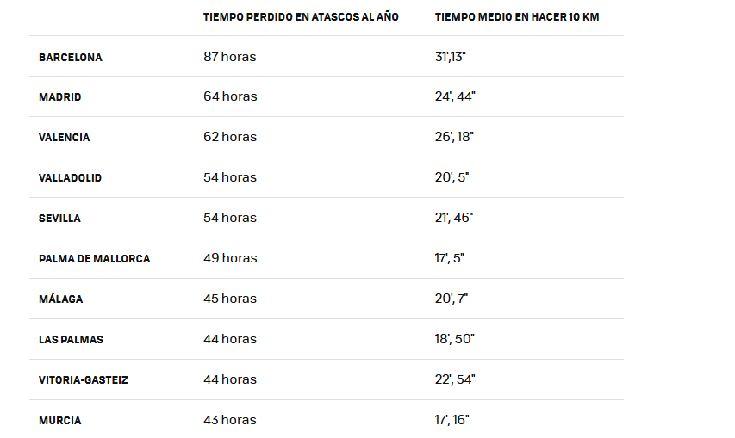
Figure 4: The ten Spanish cities with the most time lost per driver in traffic jams (from Xataka.com, with data from tomtom.com).

3.3.1.2 Urban-planning factors
Barcelona’s urban layout plays a key role in traffic flow, conditioning the city’s capacity to absorb daily vehicle flows. Its structure combines narrow, old streets typical of the historic centre with later planned expansion areas and large traffic axes. This creates notable differences in the capacity of the streets to absorb traffic and causes recurrent congestion points.
A relevant example is the Eixample, whose ordered grid makes circulation and the distribution of vehicles easier than in older areas. According to Barcelona City Council, average daily traffic in the Eixample has fallen by 17 % over the last eight years, from 350,000 to about 285,000 vehicles a day. Even so, many streets still have bottlenecks, especially at rush hour, and approximately 16.3 % of its road network suffers from high congestion.
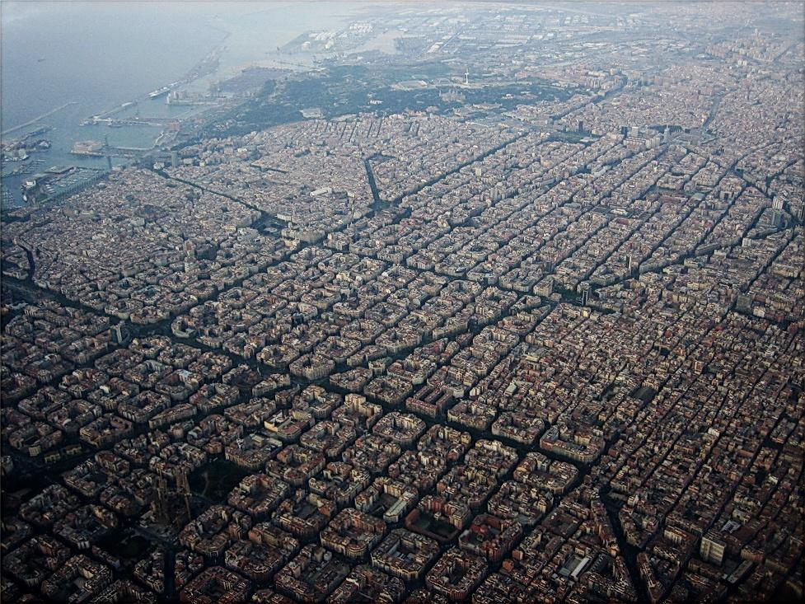
Figure 5: Aerial view of the Eixample district, Barcelona.
Compared with the historic centre of Ciutat Vella, the old streets suffer more severe and persistent congestion because of their irregular layout and limited width. Although there are no exact flow data, the Eixample concentrates one in three accidents with injuries in the whole city, which reflects the density and complexity of its traffic.
As for the major road axes, Barcelona’s ring roads (Ronda de Dalt, Ronda Litoral and Ronda del Mig) and Avinguda Diagonal act as the main corridors connecting districts and metropolitan areas. Although they were conceived to relieve inner traffic and efficiently connect the city’s access roads, they suffer constant saturation, especially at rush hour and on the stretches leading to the motorways. The coexistence of multiple modes of transport (vehicles, public transport, bicycles and pedestrians) increases the complexity of their management and makes congestion worse.
Overall, urban-planning factors show that Barcelona still faces major mobility challenges. Despite well-planned road structures and recent improvements in areas such as the Eixample, the limitations of the historic centre and the saturation of the major axes mean that traffic flow is constantly conditioned by the city’s physical structure and population density.

3.3.2 Operational factors
Apart from urban and geographical conditions, traffic efficiency in Barcelona is strongly conditioned by operational factors, that is, those related to the daily management and regulation of mobility. This management takes place through a number of traffic regulation mechanisms, which may differ depending on the area.

3.3.2.1 Traffic regulation mechanisms
Barcelona has several traffic regulation mechanisms:
- Actuated signal control: although Barcelona has some points with actuated signal control, its implementation is still limited and isolated, without global coordination between intersections. In most cases these systems act individually and reactively, adjusting the green, amber and red cycles only according to the vehicle flow at a specific junction. This lack of interconnection means that their overall impact on traffic flow is very limited, since changes at one intersection are often not transmitted to, or adapted by, neighbouring intersections.
- Speed control systems: the city has a network of fixed, mobile and section-control speed cameras that record vehicle speeds to ensure compliance with speed limits. These systems help reduce accidents, especially in urban areas with many pedestrians or near schools. Section cameras, in particular, calculate the average speed between two points, encouraging steadier and safer driving.
- Variable message signs: Barcelona also uses variable message panels located at strategic points of the road network. They display real-time information on traffic conditions, tailbacks, road closures, roadworks or weather incidents, and can show temporary speed limits or recommend alternative routes, improving drivers’ responsiveness and the overall efficiency of the road system.
- Centralised traffic management: all these mechanisms are coordinated from Barcelona’s Traffic Management Centre, which supervises mobility across the city. The centre receives real-time data from sensors, cameras and public transport systems and can act immediately in the event of incidents, jams or emergencies. However, the lack of an extensive and synchronised deployment of current systems limits the potential for fully adaptive urban traffic management.

3.3.2.2 Points of interest
Across the city there are points of interest where these mechanisms may differ from other areas. A prominent example is the Glòries tunnel, an infrastructure that, despite being intended to relieve traffic, has generated new jams at the entrance to the city.
Glòries tunnel. This tunnel, which connects Gran Via with the Besòs area, opened on 3 April 2022. Despite expectations that it would improve traffic flow, reality has been different. The long queues to enter the city from the Besòs are caused by a reduction in the number of lanes and a traffic light at the tunnel exit. More than 40,000 vehicles enter from the C-31 every day. The future use of the tunnel, now that it has been shown not to have solved the tailbacks into the Catalan capital, is uncertain. The city government has opened the door to adjusting traffic lights and has warned that it will monitor the road to prevent offences, but it does not plan bigger changes, at least for now.
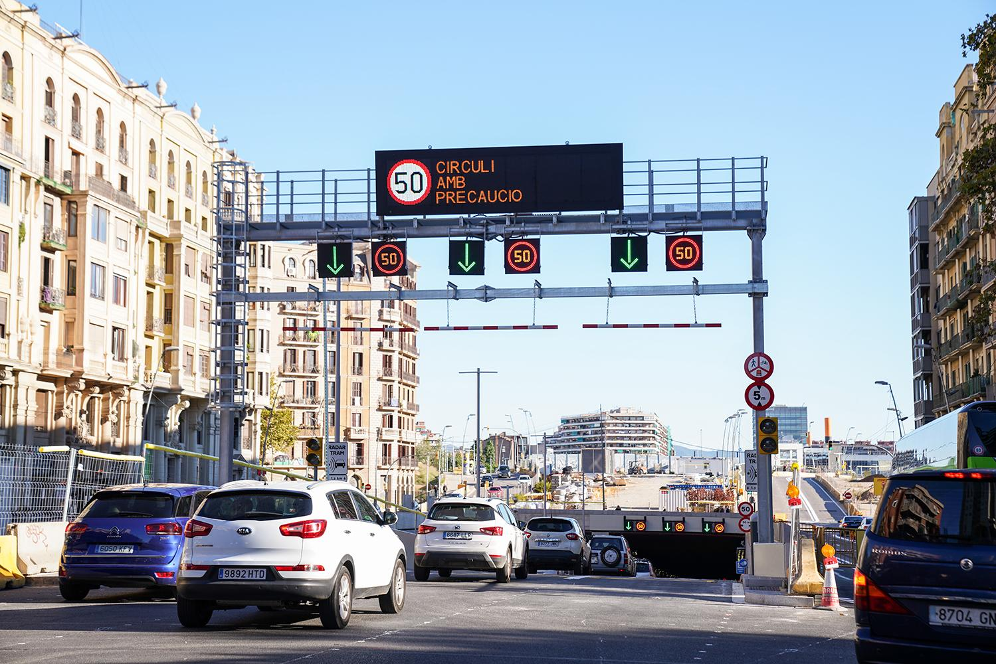
Figure 6: The Glòries tunnel, Barcelona.

4. Study of conventional traffic lights
Having analysed the real traffic situation in Barcelona, it can be concluded that one of the most effective ways of improving traffic flow is to optimise traffic signal systems. It is therefore necessary to study how traditional traffic lights work, their types, mathematical models and limitations. The aim is to identify the weaknesses that make these systems inefficient and to establish the requirements that an adaptive traffic light algorithm must meet.

4.1 Fixed-time traffic lights

4.1.1 Operation
Fixed-time traffic lights are the ones found in most cities and towns. They work with predefined cycles and phases that repeat every certain time “t”. Put more simply, a fixed-time traffic light changes from green to red every “t” units of time. These lights have no real-time responsiveness: they operate independently of the traffic and of the specific situation, which makes them ineffective in certain traffic configurations (such as saturated roads) and can make the problem worse.

4.1.2 Mathematical model
If a cycle has a duration C and each phase i has a duration gᵢ (green), yᵢ (amber) and rᵢ (all-red), the phase changes follow the relation:
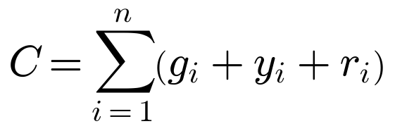 (1)
where n is the number of phases of the intersection. The key feature is that gᵢ, yᵢ and rᵢ remain constant regardless of the traffic flow λ, which causes inefficiencies when demand changes.
Fixed-time plans are not arbitrary, however. Traffic engineers choose C and the green times from the expected demand, and the classical method to do so is Webster’s formula (Webster, 1958). If yₖ = qₖ/s is the flow ratio of phase k (the flow of its busiest lane, qₖ, divided by the saturation flow s), Y = Σyₖ, and L is the total time lost in the transitions of one cycle, the cycle that minimises the average vehicle delay is approximately
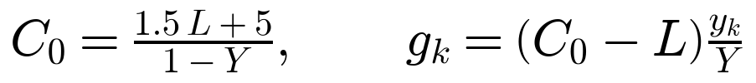 (2)
This is the method used in this project to build a fair fixed-time reference (section 7.4): a well-designed fixed-time plan is the real competitor of an adaptive system, not an arbitrary one.

4.2 Actuated traffic lights

4.2.1 Operation
Actuated traffic lights use detectors to adapt the duration of some phases according to the presence of vehicles and pedestrians in certain lanes and crossings. Although they are more responsive than fixed-time lights, their logic is often local: each intersection acts independently, without considering the state of neighbouring intersections or the queues forming on nearby roads.

4.2.2 Mathematical model
In actuated traffic lights, the duration of phase Gᵢ is no longer fixed but depends on the detected vehicle flow λᵢ. It is defined within limits:
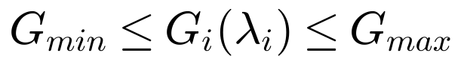 (3)
where Gᵢ(λᵢ) is the green duration of phase i as a function of the detected flow, G_min is the minimum green time the phase must keep and G_max the maximum. A simple model is:
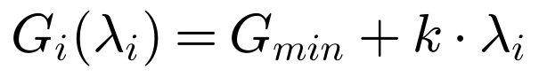 (4)
where k is a coefficient that translates “number of vehicles detected” into “additional seconds of green”. In practice, if λᵢ = 0 (no vehicle is detected) the light stays green only for the minimum time G_min, and if λᵢ is high, Gᵢ approaches G_max to allow the queue to clear. Real actuated controllers, including the one built into SUMO, implement this idea with a gap-out rule: the green is extended while vehicles keep arriving at the detector with short gaps between them, and it ends when a gap longer than a threshold appears or when G_max is reached.

4.2.3 Adaptive (traffic-responsive) traffic lights
Adaptive traffic lights change their plan according to current traffic patterns measured by sensor networks, and may use centralised algorithms to coordinate intersections. This type of traffic light makes it possible to optimise the flow more globally and to reduce delays across the whole network. Today we can find different cities and areas using this kind of signal regulation thanks, for example, to Google’s Project Green Light.

4.2.3.1 Google’s Project Green Light
Google launched Project Green Light to help cities optimise traffic light planning and reduce the emissions caused by vehicles stopping and starting. The idea is to use aggregated mobility data (for example, driving trends that can be inferred from Google Maps) to model traffic behaviour and suggest adjustments to existing signal plans, without the need to deploy costly new hardware.
General operation:
- The parameters of existing traffic lights (cycle, green phases, coordination, etc.) are inferred by analysing movement data.
- Traffic patterns are analysed (how often vehicles stop and start, mean waiting times, flows between adjacent intersections) to build a local traffic model.
- From this model, the algorithm proposes specific recommendations: for example, adding a few seconds of green at certain times, reprogramming phases or better coordinating two intersections.
- Municipal engineers review the recommendations and, if they accept them, can implement them, usually within minutes, using the existing traffic control infrastructure.
- Finally, the impact is monitored: number of stops avoided, emission reductions, redirection of flows, etc.
Preliminary results and estimated benefits: Google reports that at the intersections where Project Green Light has already been applied, stops can be reduced by up to 30 % and emissions by up to 10 %. The project is already active in several cities (at least 70 intersections in a dozen cities), and Google states that these interventions could save fuel and reduce emissions for tens of millions of journeys per month. A relevant feature is that Project Green Light does not require new installations: the recommendations are based on existing data and are applied with the signal infrastructure the city already has.
In summary, Google’s Project Green Light represents a scalable approach to adaptive traffic based on aggregated data and artificial intelligence, without the need to deploy many new sensors. This, however, limits the true efficiency and adaptability of the system, since it does not use real-time data and therefore treats traffic as a roughly constant entity, without considering its great variability.

5. Adaptive traffic lights as a solution
Given the limitations of conventional systems, an attractive way of controlling and optimising traffic flow is the use of adaptive traffic lights, as Google tries to do with Project Green Light. These devices would not only be able to react to traffic locally, but could also interact and communicate with each other, forming a coordinated network that adapts in real time to road conditions.
Adaptive traffic lights are based on a set of algorithms, presented later, that combine mathematical principles fed by a constant flow of data from sensors and cameras. Thanks to this, they would be able to predict traffic patterns and act optimally according to them. Their application would allow dynamic and global management of urban mobility, where each intersection would no longer be an isolated entity but part of an adaptive web of streets and pavements. This would help reduce congestion, improve traffic flow and reduce environmental impact, leading to a better quality of life for citizens.

5.1 Proposed models
Given the limitations of traditional signal systems, two major approaches have been developed to improve traffic management: adaptive models and intelligent models.

5.1.1 Adaptive models
Adaptive models would represent an improvement over fixed-cycle systems. Their logic is based on sensors and detection mechanisms which, interpreted by an algorithm, make it possible to adjust the duration of the phases according to real-time traffic density. In this way, traffic lights can extend or shorten the green of a lane when an accumulation of vehicles is detected. The algorithm developed in this project belongs to this family. Its closest relative in the scientific literature is max-pressure control (Varaiya, 2013), which also activates, at every moment, the phase with the highest “pressure” computed from the queues.

5.1.2 Intelligent models
Intelligent models represent a qualitative evolution over adaptive ones, since they incorporate machine-learning algorithms and advanced artificial-intelligence techniques. Thanks to this, they do not just react to the data collected by sensors and cameras, but are also able to anticipate traffic behaviour by predicting patterns and trends, based both on prior training and on historical data. In addition, these models can coordinate multiple intersections jointly, establishing an interconnected and dynamic signal network. This allows global decisions that favour traffic flow across the whole city and not only at specific points.

6. Mathematical model of the adaptive control system
To optimise traffic at an intersection by means of its traffic lights, I have developed an adaptive mathematical model based on phase pressure:
- The main objective is to prioritise vehicles without forgetting pedestrians, guaranteeing safety and fluidity.
- The model is general, applicable to any type of intersection and adaptive in real time, without depending heavily on traffic predictions, given the great variability of traffic.

6.1 State space and definition of variables
Consider a single intersection regulated by a finite set of compatible signal phases. The system is modelled in discrete time, with a step of one second:

Let X(t) be the state vector of the system at time t:
(5)
where:
- Nᵢ(t): number of vehicles in the queue of lane i at time t. How it is obtained: vehicles detected in the last 75 m before the stop line, as a camera or a long loop detector would see them. Example: if there are 7 cars in that zone of lane 1 at t = 2, N₁(2) = 7.
- λᵢ(t): arrival rate of vehicles (vehicles/s) at lane i. How it is obtained: number of vehicles that have entered the lane during the last 60 s, divided by 60. Example: if one vehicle arrives every 5 seconds, λ₁ = 0.2 veh/s.
- μᵢ: service rate (saturation flow) of lane i: the number of vehicles per second that leave a long queue when the light is green. It is a property of the lane and was measured in the simulator (section 7.2): μ = 0.493 veh/s ≈ 1777 veh/h.
- N_v^j(t): number of pedestrians waiting at crossing j at time t (people standing on the waiting area in front of that crossing). Example: if 5 pedestrians are waiting at crossing 1, N_v¹ = 5.
- T_v^j(t): waiting time of the pedestrian who has waited longest at crossing j. Example: if the oldest pedestrian at crossing 2 has been waiting for 40 seconds, T_v² = 40.
- F(t): active phase at time t.

6.2 Definition of the dynamic prioritisation functional
To decide which phase to activate, a pressure functional is associated with each phase k:
(6)
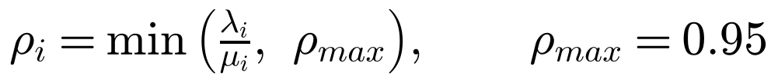
where Cₖ is the set of lanes served by phase k and Vₖ the set of pedestrian crossings that phase k opens.

6.2.1 Derivation and explanation
To understand the functional as easily as possible, it is explained term by term.

6.2.1.1 Phase compatibility factor (sₖ)
sₖ ∈ [0, 1] indicates whether the phase is safe to activate: 1 means the phase is completely safe and 0 that it is incompatible (for example, vehicles that would cross each other). It multiplies the whole pressure, so an unsafe phase has zero effective pressure. In the implementation, only conflict-free phases are ever defined, so every candidate phase has sₖ = 1, and the transitions between them (amber, all-red, pedestrian clearance) are imposed separately (section 7.3).

6.2.1.2 Vehicle pressure
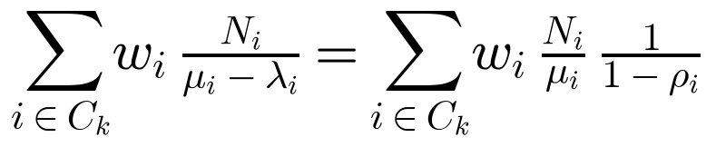
This part of the model computes the pressure exerted by vehicles:
- wᵢ gives priority to main or busier roads (in this study all lanes have wᵢ = 1, so that no road is favoured by hand).
- Nᵢ/μᵢ is the time needed to discharge the queue if no new vehicles arrived.
- 1/(1 − ρᵢ) corrects that time for the vehicles that keep arriving while the queue is being discharged.
Derivation. While lane i has green, vehicles leave the queue at rate μᵢ and new ones join it at rate λᵢ, so the queue shrinks at the net rate (μᵢ − λᵢ). The time needed to clear a queue of Nᵢ vehicles is therefore
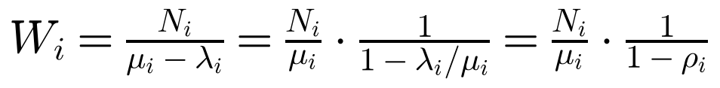 (7)
The factor 1/(1 − ρ) is the same one that appears in queueing theory: in an M/M/1 queue with utilisation ρ = λ/μ, the mean number of customers in the system is L = ρ/(1 − ρ) and the mean time in the system is W = 1/(μ − λ) (Little’s law). In both cases, the closer the arrivals get to the service capacity, the faster the delay grows, and it tends to infinity as ρ → 1.
Correction with respect to the original version
The original version of this project expanded 1/(1 − ρ) as a geometric series, 1/(1 − ρ) = 1 + ρ + ρ² + …, and kept only the first two terms, (1 + ρ). That approximation is only accurate when ρ ≪ 1, i.e. when there is little traffic, which is exactly the opposite of the situations in which the controller must react (for ρ = 0.8 the exact factor is 5, the approximation gives 1.8). The revised model therefore uses the exact expression. To keep the pressure finite when the measured arrivals approach or exceed the capacity, ρ is capped at ρ_max = 0.95, which limits the factor to 20.
In addition, the original code divided by (1 + λ/μ) instead of multiplying, so the implemented pressure decreased with saturation, contradicting section 6.5.2. The new code implements exactly the equation above, and a unit test checks it (for N = 10, μ = 0.5 and λ = 0.25 the pressure must be 40 s).

With this form the vehicle term has a clear physical meaning: it is measured in seconds and is the (weighted) time the phase would need to serve its queues. We can interpret that the more vehicles, the more saturation or the more important the road, the more pressure the phase will have.

6.2.1.3 Pedestrian pressure
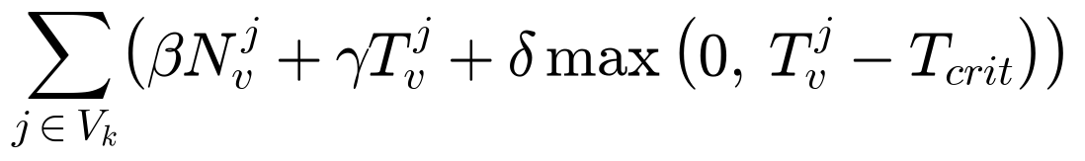
This part computes the pressure exerted by pedestrians. The weights (β, γ, δ) ≥ 0 convert people and seconds of waiting into the same units as the vehicle term, and act as the “prices” that decide how much vehicle time the system is willing to give up for pedestrians:
- β N_v^j: each waiting pedestrian adds β units of pressure.
- γ T_v^j: long waits are penalised, even if only one person is waiting.
- δ max(0, T_v^j − T_crit): extra pressure once the oldest pedestrian has waited more than the critical time T_crit. It grows without limit, so sooner or later it exceeds any vehicle pressure: no pedestrian can be left waiting indefinitely (starvation is impossible).
The values used are β = 2, γ = 0.2, δ = 5 and T_crit = 90 s. How they were chosen is explained in section 7.5.

6.3 Control policy
The decision policy of the system is defined as:
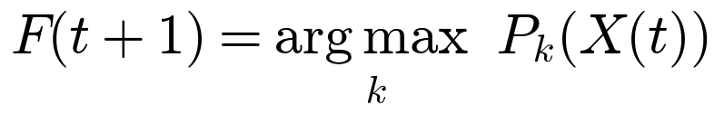 (8)
subject to the time constraints
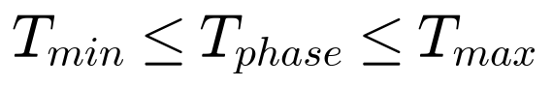 (9)
This rule is a local maximisation policy: at every second, the phase with the highest instantaneous pressure is activated, and each green lasts a minimum and a maximum time. Precisely:
- Before T_min = 10 s the current green is never interrupted (it also guarantees pedestrians enough time to start crossing).
- Between T_min and T_max, the controller switches to the phase of highest pressure if its pressure is strictly greater than that of the current phase.
- At T_max = 90 s it switches to the other phase with the highest pressure, provided that phase has any demand at all; if nobody is waiting elsewhere, the current green continues.
- Every switch runs a safe transition: pedestrian clearance, amber and all-red (section 7.3). During the transition no new decision is taken.
The system is therefore a control mechanism with full state feedback.

6.4 Interpretation in terms of optimisation
We can consider the overall cost of the system:
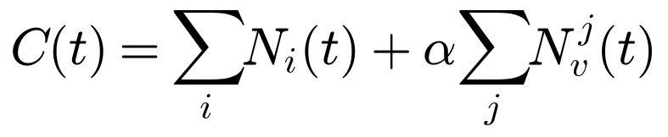 (10)
This functional represents the weighted total number of users waiting. The policy does not explicitly solve min C(t) over the whole horizon, but it acts as a greedy approximation: at each moment it serves the group of users whose waiting would be most costly, which reduces the accumulated cost locally. This is the same principle as max-pressure control (Varaiya, 2013), for which it has been proven that serving the phase of greatest pressure keeps queues bounded whenever the demand is within the capacity of the intersection.

6.5 Theoretical properties of the model

6.5.1 Non-negativity
Since all variables and weights are non-negative and ρᵢ < 1, it holds that Pₖ(X(t)) ≥ 0 for every phase.

6.5.2 Sensitivity to saturation
If λᵢ → μᵢ, the factor 1/(1 − ρᵢ) grows rapidly (up to the cap 1/(1 − ρ_max)), increasing the pressure. This allows situations close to collapse to be detected and served first. (With the first-order approximation of the original version the factor could never exceed 2.)

6.5.3 Limit behaviour
If λᵢ(t) → 0 for all i, then Nᵢ(t) → 0 and the pedestrian terms also vanish, so every pressure tends to zero and the controller simply rests in the current green without oscillating.

6.5.4 No starvation
Because the δ term grows linearly without limit after T_crit, and because every green is limited to T_max, every phase with demand is served within a bounded time. In the simulations, the longest pedestrian wait observed is reported in chapter 8 as a check of this property.

6.6 Limitations of the model
Despite the results obtained in simulation, the proposed algorithm has certain intrinsic limitations that must be considered for a future real implementation:
- Local optimum vs. global optimum: the algorithm is designed to maximise flow at a specific intersection based on the immediate sensor data. However, an improvement at a specific point (local optimum) can create bottlenecks at adjacent intersections, not necessarily guaranteeing the best performance for the whole road network (global optimum).
- Sensitivity to calibration and oscillations: the system depends on the weights given to each variable (pedestrians vs. vehicles). If these parameters are not properly calibrated for the street, the system may switch phases too often and lose efficiency because of the transition times. Section 7.5 describes how they were calibrated in this study, and chapter 8 shows their effect.
- Myopic decisions: the controller only sees the current queues. It cannot know that a platoon of vehicles is about to arrive, so it may cut a green just before it would have been most useful.
- Complexity in high-density networks: extending this model to a city like Barcelona would require an inter-node coordination architecture. Without communication between neighbouring traffic lights, “green waves” could be broken, since each light would take selfish decisions based only on its own pressure.
- Human factor and external variables: the SUMO simulation assumes rational behaviour. In reality, variables such as pedestrian offences, badly parked vehicles obstructing sensors or weather conditions introduce noise that the current algorithm does not directly take into account.
- Dependence on sensor infrastructure: the feasibility of the project is tied to the accuracy of data capture. Errors in computer-vision systems or induction loops could lead the model to wrong decisions, requiring fail-safe protocols (reverting to a fixed cycle) not developed at this stage.
These limitations do not invalidate the model, but they define its scope and open lines for future research.

7. Simulation of the adaptive traffic lights

7.1 Creation of the digital environment
To test the algorithm, it is first necessary to create the environment in which to simulate it. This was done with SUMO (Simulation of Urban MObility).

7.1.1 Simulation of Urban MObility (SUMO)
SUMO is open-source software designed for urban traffic simulation (López et al., 2018). It makes it possible to build road environments and to simulate the behaviour of every vehicle and pedestrian individually (microscopic simulation) on a given road infrastructure. It can be connected to external algorithms through the TraCI interface, programmable in Python, which allows traffic lights to be controlled and statistics to be collected during the simulation. I chose SUMO because it focuses on customisable infrastructures, allows the traffic lights to be controlled as the algorithm requires, and produces objective data that are key to evaluating the adaptive system. The revised simulations use SUMO 1.27.1.

7.1.2 Development of the road infrastructure
More than one type of intersection was developed, since each has different characteristics and traffic dynamics. This diversity makes it possible to evaluate the signal systems more realistically and to check to what extent the proposed solutions adapt to different contexts. All the networks were designed by me with SUMO’s network editor (netedit).

7.1.2.1 Simple intersection: two-way road with a pedestrian crossing
This configuration is the most basic case: a two-way road with a single pedestrian crossing connecting the two pavements. It is an elementary scenario that allows the minimum functioning of the traffic lights and the direct interaction between vehicles and pedestrians at a specific point to be analysed.

Figure 7: The simple intersection in SUMO.
It contains a two-way road with one lane per direction (speed limit 50 km/h), a pavement on each side, a pedestrian crossing (6.4 m long) and a traffic light with two phases: vehicles green, or pedestrians green. The demand, taken from the original route file, is:
- A random flow of vehicles in each direction, with an insertion probability of 0.3 per second (on average 1,080 vehicles/hour per direction).
- Four random flows of pedestrians, with probability 0.03 per second each, starting on either pavement; half of them cross the road and half continue along their pavement.

7.1.2.2 Multiple intersection: two-way road with several pedestrian crossings
This model extends the previous case by incorporating several pedestrian crossings (five) on the same stretch of two-way road, each with its own traffic light. Vehicles must therefore compete with several pedestrian flows along the same stretch.

Figure 8: Multiple intersection (two-way road with several crossings) in SUMO.
For this network a specific adaptive algorithm was not developed: the main challenge here is the coordination between consecutive traffic lights (“green waves”), which is a network problem beyond the single-intersection model of this project (see section 9.2). It is therefore not included in the comparison of chapter 8.

7.1.2.3 Shibuya-type intersection
Inspired by the Shibuya crossing (Tokyo), this configuration is a four-arm intersection where vehicles and pedestrians move in several directions (without the diagonal crossing). It is especially complex, since each arm has a single lane per direction shared by left-turning, straight and right-turning vehicles, and pedestrians cross the four arms.
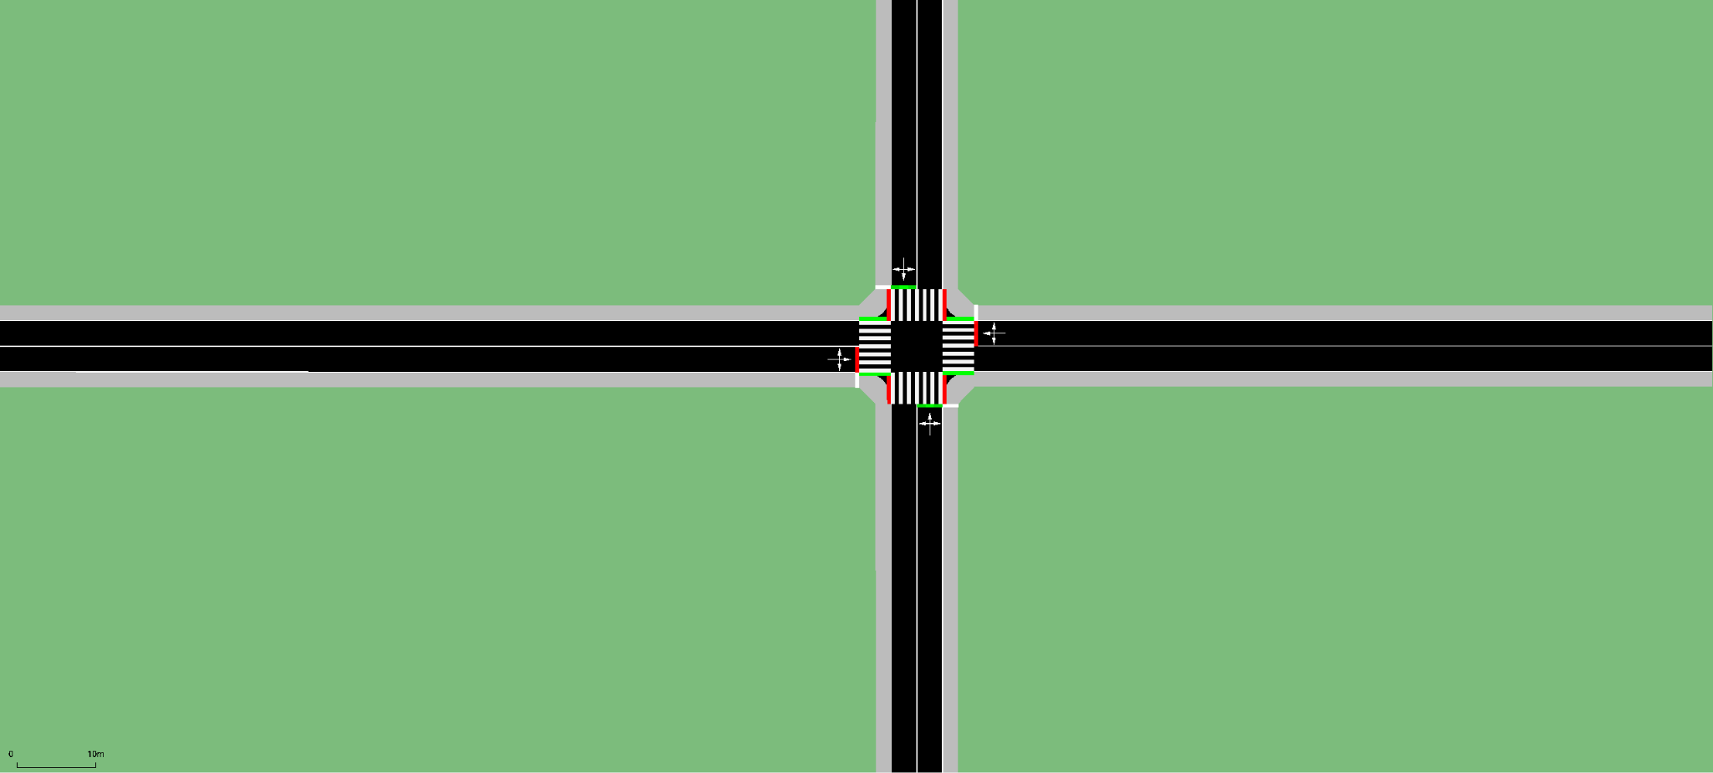
Figure 9: The Shibuya-type intersection in SUMO.
It contains four two-way arms (one lane per direction), pavements on both sides, four pedestrian crossings (one per arm) and one traffic light with two phases: north–south vehicles together with the crossings parallel to them, and east–west vehicles with their parallel crossings. Turning vehicles must give way to pedestrians on the crossing they cut, and left-turning vehicles must also give way to oncoming traffic. The demand of the original route file is:
- Three vehicle flows per arm (left, straight and right), each with probability 0.07 per second: 0.21 veh/s ≈ 756 vehicles/hour per approach, 3,024 vehicles/hour in total.
- Seven pedestrian flows of 0.07 people per second each, starting from the western arm towards the other arms (about 1,760 pedestrians/hour).
This demand deliberately represents a collapsed intersection: as chapter 8 shows, no signal plan can serve it, because vehicles waiting to turn left in a shared lane block everyone behind them.

7.2 Measuring the saturation flow μ
The model needs the service rate μ of each lane. Instead of choosing it by hand (the original code used μ = 1.8 veh/s, i.e. 6,480 veh/h per lane, more than three times what a real urban lane can discharge), it was measured in SUMO with the standard queue-discharge method: the lane is kept red for 90 s until a long queue forms, then it gets green and the vehicles leaving the lane between 5 s and 35 s after the start of green are counted (the first seconds are excluded because of the start-up lost time). Repeated over 36 green periods, the result is
which is very close to the typical saturation flow of an urban lane given in traffic engineering manuals (about 1,800 veh/h). All approaches in both networks have the same geometry, so this value is used for every lane.

7.3 Implementation of the adaptive controller
The algorithm is connected to SUMO through TraCI. Every simulated second, the controller:
1. reads each incoming lane: the vehicles in the last 75 m (Nᵢ) and the vehicles that entered the lane during the last 60 s (to compute λᵢ);
2. reads each crossing: the pedestrians waiting on the waiting area in front of it (N_v^j) and the longest waiting time among them (T_v^j);
3. computes Pₖ for every phase with the equation of section 6.2 and applies the policy of section 6.3;
4. sets the state of every signal explicitly with setRedYellowGreenState.
The transition between two phases is generated automatically by comparing the two signal states, so it is always safe and identical for the three controllers:
- Pedestrian clearance (6 s): crossings that lose their green turn red first, while vehicles keep their current signal. The duration is the crossing length divided by a design walking speed of 1.2 m/s, so that anyone who has just stepped onto the crossing can finish.
- Amber (3 s) for the vehicle movements that lose green.
- All-red (2 s) before the new green starts.
Correction with respect to the original version
The original scripts used setPhase, which jumps to a phase of the static program stored in the network file; SUMO then keeps running that program on its own. In the simple intersection the pedestrian phase of that program lasted only 5 s, after which SUMO returned the green to vehicles by itself while the script believed pedestrians still had green. In the Shibuya intersection the script treated phases 0, 1, 2 and 3 as “north, south, east, west”, but phase 2 was actually an amber and phase 4 (used as “amber”) was a green, and the pedestrian pressure was added equally to all phases, so it never influenced any decision. These problems are fixed in the new implementation, and unit tests check that no transition ever gives green to two conflicting movements.

7.4 Reference controllers
To know whether the adaptive algorithm is good, it must be compared with what traffic engineers would actually install. Two references are used; both use exactly the same phases and transitions as the adaptive controller.

7.4.1 Fixed-time plan (Webster)
For every scenario and demand level, the cycle length and the green times are computed with Webster’s method (section 4.1.2) from the expected flows and the measured μ. In the simple intersection, the pedestrian phase has no vehicle flow, so it receives the minimum walk time of 10 s, which is counted as lost time for vehicles. The cycle is limited to 30–120 s, as is usual in practice; when the flow ratios add up to 0.95 or more (an oversaturated intersection) the maximum cycle of 120 s is used. Table 2 shows the resulting plans.
Table 2: Fixed-time plans computed with Webster’s method (greens include the pedestrian clearance during which vehicles keep moving).
Intersection | Demand | Y = Σyₖ | Lost time L | Cycle C | Greens
Simple | 25 % | 0.15 | 21 s | 43 s | veh 22 s / ped 10 s
Simple | 50 % | 0.30 | 21 s | 52 s | veh 31 s / ped 10 s
Simple | 75 % | 0.46 | 21 s | 67 s | veh 46 s / ped 10 s
Simple | 100 % | 0.61 | 21 s | 93 s | veh 72 s / ped 10 s
Shibuya | 20 % | 0.17 | 10 s | 42 s | 16 s / 16 s
Shibuya | 30 % | 0.26 | 10 s | 42 s | 16 s / 16 s
Shibuya | 40 % | 0.34 | 10 s | 42 s | 16 s / 16 s
Shibuya | 50 % | 0.43 | 10 s | 42 s | 16 s / 16 s
Shibuya | 75 % | 0.64 | 10 s | 55 s | 23 s / 23 s
Shibuya | 100 % | 0.85 | 10 s | 120 s | 55 s / 55 s
Shibuya (unbalanced) | — | 0.47 | 10 s | 51 s | 16 s / 25 s

All three controllers apply the same minimum-green rule: every phase shows its full green for at least T_min = 10 s before its transition starts. In the Shibuya intersection, vehicles keep their green during the pedestrian clearance that follows, so the shortest possible vehicle green is 10 + 6 s.
The original fixed-time script used a 30 s green, a 10 s amber, a 30 s pedestrian green and a 5 s all-red. A 10-second amber is far longer than the usual 3–5 s and, together with the arbitrary green times, made the original baseline much worse than a real fixed-time light.

7.4.2 Actuated controller (SUMO)
SUMO includes a gap-based actuated controller: detectors placed before the stop line extend the green while vehicles keep arriving less than 3 s apart, between a minimum green of 10 s and a maximum green (the same T_max as the adaptive controller). It represents the actuated signals already used at some points in Barcelona (section 3.3.2.1). In the simple intersection the pedestrian phase has no detector, so it is served every cycle for 10 s, as at a crossing without a push button.

7.5 Calibration of the controller parameters
The adaptive controller has free parameters that the original version fixed by hand: the maximum green T_max, the critical pedestrian time T_crit and the pedestrian weights β and γ. They decide how the controller balances vehicles against pedestrians, so they were chosen systematically with a grid search:
- T_max ∈ {30, 40, 60, 90, 120} s, T_crit ∈ {30, 45, 60, 90, 120} s, and a multiplier of {0.5, 1, 2} applied to β and γ (base values β = 2, γ = 0.2, δ = 5): 75 combinations.
- Each combination was simulated in four representative cases (both intersections, at low and at full demand) with three tuning seeds (101–103). These seeds are never used in the evaluation of chapter 8 (seeds 1–20), so the reported results are not fitted to the data they are evaluated on.
- The objective is the total person-delay: 1.2 × (sum of vehicle delays) + (sum of pedestrian waiting times), where 1.2 is the average occupancy of a car. It counts one second of a person waiting the same whether that person is in a car or on foot. It is expressed relative to the Webster plan in each case and averaged over the four cases.
- The same grid of maximum greens was applied to the actuated controller, so that it is calibrated as carefully as the adaptive one.
The best combination was T_max = 90 s, T_crit = 90 s and the original pedestrian weights (multiplier 1). Several neighbouring combinations (T_max and T_crit between 90 and 120 s) gave practically the same result, so the choice is not sensitive to small changes. Relative to Webster, the person-delay of the tuned adaptive controller on the tuning seeds was simple at 0.5: 0.98, simple at 1: 0.99, shibuya at 0.3: 0.94, shibuya at 1: 0.91 (mean 0.96; values below 1 mean less person-delay than Webster). For the actuated controller the best maximum green was 40 s (mean 2.26).
Table 3: Parameters of the adaptive controller.
Parameter | Original version | Revised version
Pressure saturation factor | (1 + λ/μ) (code: divided) | 1/(1 − ρ), ρ ≤ 0.95
Service rate μ | 1.8 veh/s (assumed) | 0.493 veh/s (measured)
Arrival rate λ | |Δ vehicles on lane| / 30 s | entries / 60 s
Queue Nᵢ | vehicles slower than 5–8 m/s | vehicles in last 75 m
Lane weights wᵢ | 1.0–1.5 (by hand) | 1.0 (all lanes)
T_min | 10 s | 10 s
T_max | 25–30 s | 90 s (tuned)
Amber / all-red | 3–5 s / none | 3 s / 2 s
Pedestrian clearance | none | 6 s
β, γ, δ | 2–2.5, 0.2, 4–5 | 2, 0.2, 5
T_crit | 30–40 s | 90 s (tuned)

8. Results and analysis
Once the simulations had been completed, the results were collected and analysed. All the results of this chapter were obtained with the revised code; the results of the original version are compared with them in section 8.6.

8.1 Methodology and evaluation metrics
Vehicle and pedestrian flows are random: every second, each flow inserts a new vehicle or pedestrian with a certain probability. This stochastic component reproduces the variability of real traffic, but it also means that a single simulation can be lucky or unlucky. Therefore:
- Every case (intersection × demand level × controller) was simulated with 20 different random seeds (1–20). The three controllers use the same seeds, so they face exactly the same sequence of arrivals, and they can be compared seed by seed (paired comparison).
- Results are given as the mean ± the half-width of the 95 % confidence interval (Student’s t distribution). If two intervals do not overlap, the difference is very unlikely to be due to chance.
- Vehicle demand was varied from low to very high as a percentage of the demand of the original route files (100 %), while pedestrian demand was kept at its original value. This shows how each controller behaves from light traffic to collapse.
- Demand is generated for one hour; the simulation then continues (up to 30 more minutes) until the queues have emptied.
All controllers are measured with the same SUMO output (tripinfo), never with values computed by the controllers themselves. The metrics are:
- Mean vehicle delay (primary metric): time lost by each vehicle compared with driving at its desired speed (SUMO’s timeLoss), plus the time it had to wait before it could even enter a full road (departDelay). Vehicles still queuing when the simulation stops are included with their delay so far, so a controller cannot look good by leaving vehicles out.
- Mean vehicle waiting time (Wᵥ): time spent stopped (speed below 0.1 m/s).
- Mean pedestrian waiting time (Wₚ): time spent standing still by the pedestrians who used a signalised crossing. The longest wait is also reported, to check the no-starvation property of section 6.5.4.
- Throughput: vehicles that completed their trip during the first hour.
- Delay per person: vehicle delay counted 1.2 times (average car occupancy) plus pedestrian waiting, divided by the number of people. It weighs one second of a person waiting equally in a car or on foot.
- CO₂ per vehicle: from SUMO’s HBEFA emission model (section 8.5).
To quantify the improvement, the same ratio defined in the original version of the project is used, now computed for each seed and then averaged:
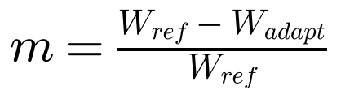 (11)
If m > 0 the adaptive controller is better than the reference (fixed-time or actuated); if m < 0 the reference is better. In the tables, the number in brackets is the number of seeds in which the adaptive controller was better, for example (18/20).

8.2 Simple intersection: two-way road with a pedestrian crossing
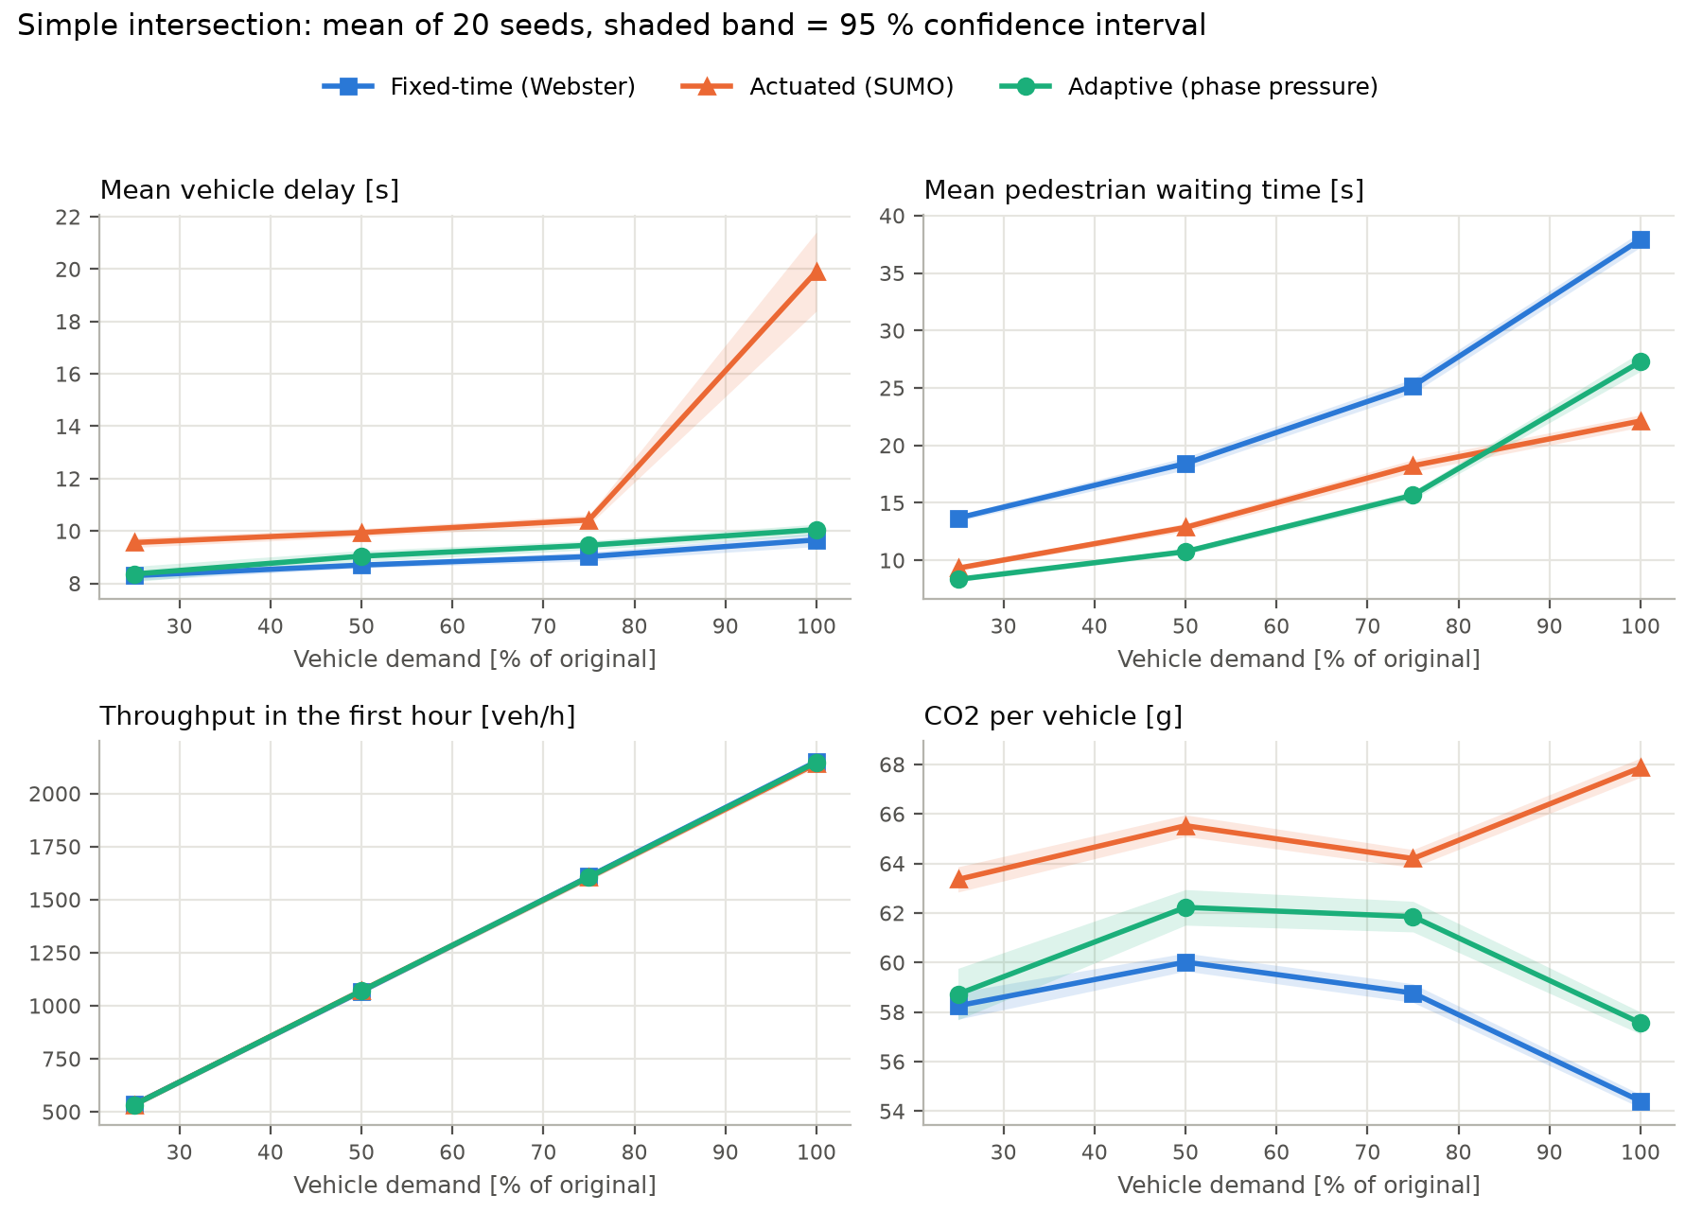
Figure 10: Simple intersection: results as a function of vehicle demand (100 % = the original demand of 0.3 vehicles/s per direction).
Table 4: Simple intersection: mean vehicle delay [s] (mean ± 95 % CI, 20 seeds).
Demand | Fixed-time (Webster) | Actuated | Adaptive
25 % | 8.3 ± 0.2 | 9.6 ± 0.2 | 8.4 ± 0.3
50 % | 8.7 ± 0.1 | 9.9 ± 0.2 | 9.0 ± 0.2
75 % | 9.0 ± 0.2 | 10.4 ± 0.2 | 9.5 ± 0.2
100 % | 9.7 ± 0.3 | 19.9 ± 1.5 | 10.1 ± 0.2

Table 5: Simple intersection: mean pedestrian waiting time [s].
Demand | Fixed-time (Webster) | Actuated | Adaptive
25 % | 13.7 ± 0.3 | 9.3 ± 0.2 | 8.3 ± 0.2
50 % | 18.4 ± 0.5 | 12.9 ± 0.3 | 10.8 ± 0.3
75 % | 25.2 ± 0.6 | 18.2 ± 0.5 | 15.7 ± 0.4
100 % | 37.9 ± 0.7 | 22.1 ± 0.5 | 27.3 ± 0.8

Table 6: Simple intersection: improvement m of the adaptive controller (paired by seed; positive = adaptive better).
Demand | Vehicle delay vs fixed | vs actuated | Pedestrian wait vs fixed | vs actuated | Delay per person vs fixed
25 % | -1 ± 4 % (7/20) | +12 ± 4 % (19/20) | +39 ± 2 % (20/20) | +10 ± 3 % (19/20) | +13 ± 2 % (20/20)
50 % | -4 ± 2 % (5/20) | +9 ± 2 % (19/20) | +41 ± 2 % (20/20) | +16 ± 3 % (20/20) | +8 ± 2 % (19/20)
75 % | -5 ± 3 % (2/20) | +9 ± 2 % (20/20) | +38 ± 2 % (20/20) | +14 ± 3 % (20/20) | +5 ± 2 % (19/20)
100 % | -4 ± 3 % (5/20) | +48 ± 3 % (20/20) | +28 ± 3 % (20/20) | -24 ± 5 % (0/20) | +4 ± 2 % (17/20)

Vehicles. With the adaptive controller, vehicles lose practically the same time as with the Webster fixed-time plan: the difference is between +0.1 and +0.4 s per vehicle (+1 to +5 %), slightly in favour of the fixed-time plan. This is expected: Webster’s method is designed precisely to minimise vehicle delay when the demand is known and constant, which is exactly the situation simulated here. The throughput is the same for all controllers (differences below 0.2 %), because at this intersection all of them can serve all the vehicles. Compared with the actuated controller, however, the adaptive one reduces vehicle delay by 9–48 % at every demand level; at 100 % demand the actuated controller starts to struggle, because it serves the pedestrian phase every cycle even when nobody is waiting.
Pedestrians. This is where the adaptive controller makes a clear difference. Pedestrians wait 28–42 % less than with the fixed-time plan, in all 20 seeds of every demand level. The fixed-time plan gives vehicles long greens (its cycle reaches 93 s at 100 % demand) and pedestrians must wait for the next cycle regardless of how many are waiting; the adaptive controller opens the crossing when the pedestrian pressure justifies it (mean cycle 74 s). Only at 100 % demand does the actuated controller give pedestrians shorter waits (24 % less than adaptive), at the cost of doubling the vehicle delay.
Per person. Counting everyone who waits, the adaptive controller reduces the delay per person by 4–13 % compared with the fixed-time plan. The longest pedestrian wait observed with the adaptive controller was 94 s (mean of the maximum over the 20 seeds at 100 % demand), just above T_crit = 90 s: the δ term of section 6.2.1.3 does guarantee that nobody waits indefinitely, but with the calibrated T_crit the guarantee only acts after a long wait.

8.3 Shibuya-type intersection
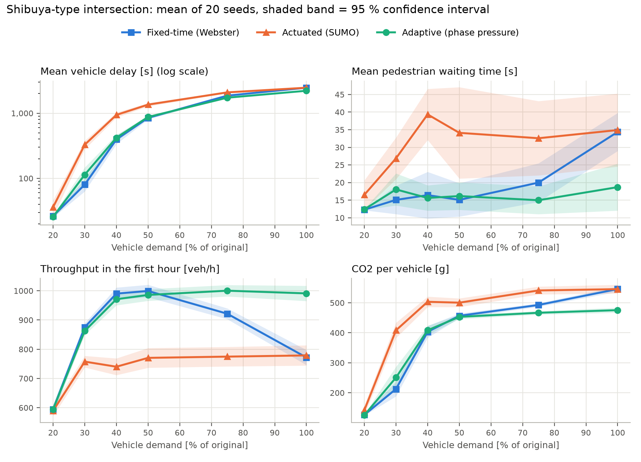
Figure 11: Shibuya-type intersection: results as a function of vehicle demand (100 % = the original demand of 756 vehicles/h per approach). The delay axis is logarithmic.
Table 7: Shibuya-type intersection: mean vehicle delay [s].
Demand | Fixed-time (Webster) | Actuated | Adaptive
20 % | 26 ± 1 | 36 ± 10 | 26 ± 2
30 % | 80 ± 17 | 329 ± 50 | 114 ± 33
40 % | 396 ± 60 | 942 ± 86 | 420 ± 45
50 % | 849 ± 47 | 1,355 ± 81 | 874 ± 47
75 % | 1,860 ± 35 | 2,088 ± 59 | 1,730 ± 39
100 % | 2,462 ± 36 | 2,462 ± 50 | 2,211 ± 38

Table 8: Shibuya-type intersection: throughput in the first hour [veh/h].
Demand | Fixed-time (Webster) | Actuated | Adaptive
20 % | 595 ± 15 | 589 ± 18 | 594 ± 15
30 % | 876 ± 14 | 758 ± 20 | 863 ± 14
40 % | 990 ± 21 | 740 ± 29 | 971 ± 21
50 % | 999 ± 21 | 771 ± 34 | 986 ± 20
75 % | 922 ± 19 | 775 ± 33 | 1,000 ± 20
100 % | 772 ± 26 | 779 ± 35 | 991 ± 26

Table 9: Shibuya-type intersection: mean pedestrian waiting time [s].
Demand | Fixed-time (Webster) | Actuated | Adaptive
20 % | 12.3 ± 0.1 | 16.5 ± 4.1 | 12.4 ± 0.1
30 % | 15.1 ± 4.0 | 26.9 ± 5.9 | 18.0 ± 4.5
40 % | 16.4 ± 6.6 | 39.3 ± 7.3 | 15.6 ± 3.6
50 % | 15.1 ± 4.7 | 34.1 ± 13.0 | 16.2 ± 3.9
75 % | 20.0 ± 5.5 | 32.6 ± 10.6 | 15.0 ± 3.9
100 % | 34.4 ± 5.4 | 34.9 ± 10.4 | 18.7 ± 6.7

Table 10: Shibuya-type intersection: improvement m of the adaptive controller (paired by seed; positive = adaptive better).
Demand | Vehicle delay vs fixed | vs actuated | Pedestrian wait vs fixed | vs actuated | Delay per person vs fixed
20 % | +2 ± 4 % (12/20) | +16 ± 11 % (17/20) | -1 ± 1 % (7/20) | +15 ± 9 % (19/20) | +1 ± 2 % (12/20)
30 % | -44 ± 34 % (4/20) | +64 ± 9 % (20/20) | -32 ± 33 % (3/20) | +27 ± 21 % (16/20) | -40 ± 33 % (2/20)
40 % | -12 ± 12 % (4/20) | +54 ± 5 % (20/20) | -20 ± 33 % (6/20) | +53 ± 14 % (19/20) | -12 ± 13 % (4/20)
50 % | -4 ± 5 % (4/20) | +35 ± 4 % (20/20) | -21 ± 30 % (7/20) | +43 ± 15 % (18/20) | -4 ± 5 % (4/20)
75 % | +7 ± 3 % (19/20) | +17 ± 2 % (20/20) | +8 ± 30 % (18/20) | +42 ± 20 % (18/20) | +7 ± 3 % (18/20)
100 % | +10 ± 2 % (20/20) | +10 ± 2 % (19/20) | +42 ± 21 % (16/20) | +29 ± 31 % (16/20) | +10 ± 2 % (20/20)

A collapsed intersection. The first thing the figure shows is that this intersection cannot serve the original demand with any of the controllers. Its real capacity is about 1,000 vehicles/hour, far below the 3,024 vehicles/hour of the original route file: from about 40 % of the original demand onwards, queues grow during the whole hour and the delay reaches many minutes per vehicle (most of it waiting to enter the network). The reason is geometric: each approach has a single lane shared by all movements, so a vehicle waiting to turn left (which must give way to oncoming traffic and to pedestrians) blocks all the vehicles behind it.
Low demand (20 %). With little traffic the three controllers are similar (delays around 26–26 s); the adaptive and fixed-time controllers are statistically indistinguishable.
Intermediate demand (30–50 %). Here the fixed-time plan is the best: at 30 % demand the adaptive controller has a mean delay of 114 s against 80 s for Webster, and it loses in most seeds up to 50 %, although the difference shrinks as demand grows (at 50 % it is no longer significant). The most likely explanation is a limitation of the model itself: the vehicle term assumes that a queue is discharged at the saturation flow μ, but in a shared lane blocked by a left-turning vehicle almost nobody moves. The controller then sees a long queue with high pressure and keeps giving it green even though that green is being wasted, while the fixed plan simply moves on after a short, regular green.
Saturation (75–100 %). When the intersection is completely saturated, the adaptive controller becomes the best one: it reduces vehicle delay by 7 % and 10 % compared with the fixed-time plan and increases throughput by 9 % and 28 %, with lower pedestrian waits (46 % less at 100 %). Webster’s formula is not designed for this situation: as the flow ratios approach 1 it prescribes ever longer cycles (the maximum, 120 s, at 100 % demand), and long greens are wasted behind blocked left-turners. The adaptive controller keeps changing phase every ~21 s (cycle 43 s), which regularly clears the blocked vehicles.
Against the actuated controller, the adaptive one is better at every demand level (10–64 % less vehicle delay), and pedestrians also wait less. SUMO’s actuated controller keeps extending the green while vehicles cross its detectors, which here produces very long cycles (around 100 s) and long waits for everyone else.

8.4 Shibuya-type intersection with unbalanced demand
As in the original version, a second Shibuya experiment was run in which one approach carries much more traffic than the others: the three flows from the west keep their probability of 0.07 vehicles/s each, while all the other flows are reduced to 0.007. An adaptive controller should be especially useful here, since the demand is very different from one direction to another.
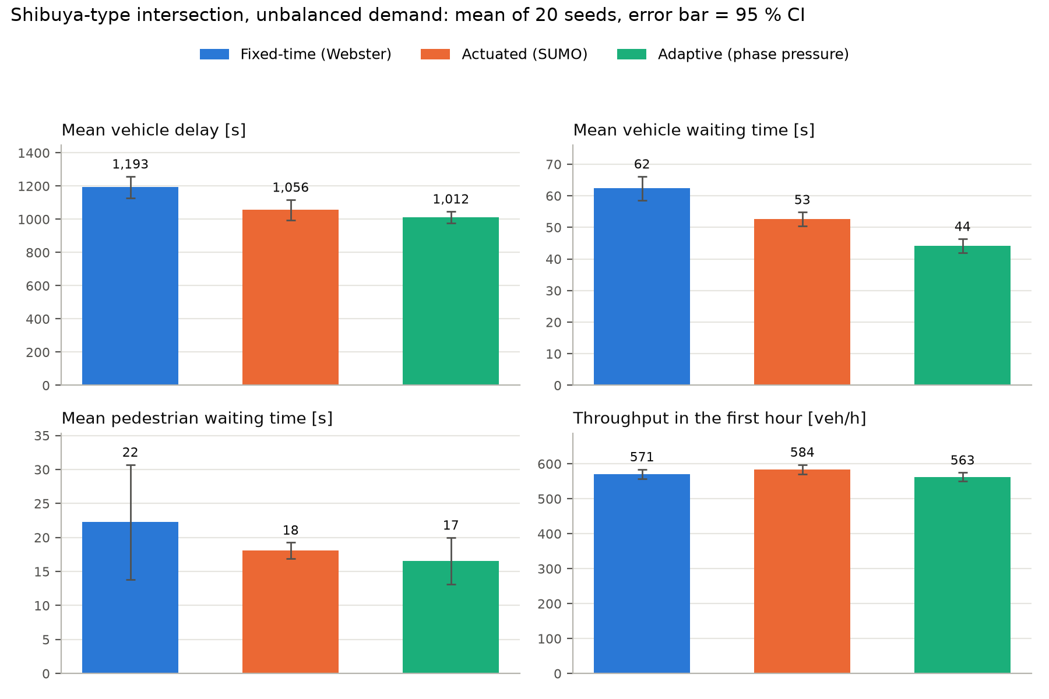
Figure 12: Shibuya-type intersection with unbalanced demand (20 seeds).
Table 11: Shibuya-type intersection with unbalanced demand.
Metric | Fixed-time (Webster) | Actuated | Adaptive
Mean vehicle delay [s] | 1,193 ± 64 | 1,056 ± 61 | 1,012 ± 35
Mean vehicle waiting time [s] | 62.4 ± 3.7 | 52.6 ± 2.2 | 44.2 ± 2.2
Throughput [veh/h] | 571 ± 13 | 584 ± 14 | 563 ± 12
Mean pedestrian waiting time [s] | 22.2 ± 8.5 | 18.1 ± 1.2 | 16.5 ± 3.4
Longest pedestrian wait [s] | 133 ± 85 | 86 ± 29 | 107 ± 50
CO₂ per vehicle [g] | 262 ± 6 | 241 ± 4 | 221 ± 4

The adaptive controller reduces vehicle delay by 15 ± 3 % compared with the fixed-time plan (better in 20/20 seeds) and the time vehicles spend stopped by 29 %. Compared with the actuated controller the difference in delay (+3 ± 5 %) is not significant. Throughput is similar for the three controllers, and pedestrians wait about the same with the adaptive and fixed-time controllers (the differences are within the confidence intervals). The original version reported a 40 % vehicle improvement and a 66 % worsening for pedestrians in this experiment; with the corrected code, pedestrians are not penalised.

8.5 Emissions and the question of Barcelona
SUMO can estimate the emissions of every vehicle with the HBEFA model, which takes into account the speed and acceleration of the vehicle at every second (a car that stops and starts again emits more than one that keeps moving). Table 12 gives the CO₂ emitted per vehicle while crossing the network.
Table 12: CO₂ emitted per vehicle [g] (HBEFA model in SUMO).
Case | Fixed-time | Actuated | Adaptive | Adaptive vs fixed
Simple, 50 % | 60 ± 0 | 66 ± 0 | 62 ± 1 | +4 %
Simple, 100 % | 54 ± 0 | 68 ± 0 | 58 ± 0 | +6 %
Shibuya, 30 % | 213 ± 24 | 408 ± 26 | 251 ± 36 | +18 %
Shibuya, 100 % | 546 ± 9 | 546 ± 15 | 476 ± 8 | -13 %
Shibuya, unbalanced | 262 ± 6 | 241 ± 4 | 221 ± 4 | -16 %

Emissions follow the delays: they are lower with the adaptive controller where it reduces stop-and-go traffic (saturated and unbalanced Shibuya) and slightly higher where the fixed-time plan keeps vehicles moving better (simple intersection, Shibuya at intermediate demand).
Why the extrapolation to Barcelona has been removed
The original version multiplied Barcelona’s daily figures (63,000 hours lost at the metropolitan access roads, €650,000 per day, the 54 % of NOx and 40 % of particles due to traffic) by the improvement obtained in one simulated intersection. That calculation is not valid, for several reasons: most of those hours are lost on motorways and access roads, not at traffic lights; a single isolated intersection with invented demand does not represent a whole city network; the NOx and particle percentages describe all road traffic and do not scale with the waiting time at signals; and, as this chapter shows, the improvement is not a single number but depends strongly on the demand.
What the simulations do support is a qualitative statement: at intersections that are saturated or have strongly unbalanced demand, an adaptive controller can reduce delay and emissions by around 5–15 % compared with a well-designed fixed-time plan, and by more compared with a simple actuated controller. Estimating the effect for Barcelona would require simulating a real part of the city (for example an Eixample corridor) with measured traffic counts.

8.6 Comparison with the results of the original version
Table 13: Improvement m of the adaptive controller at the original demand: original version against revised version (positive = adaptive better).
Experiment | Original version (1 run) | Revised (20 seeds, vs Webster)
Simple, vehicles | +80 % | -4 ± 3 %
Simple, pedestrians | 0 % | +28 ± 3 %
Shibuya, vehicles | +60 % (+68 % with the table values) | +10 ± 2 %
Shibuya, pedestrians | −15 % | +42 ± 21 %
Shibuya unbalanced, vehicles | +40 % | +15 ± 3 %
Shibuya unbalanced, pedestrians | −66 % | -3 ± 30 %

The differences are explained by errors in the original code and method, corrected in this edition (sections 6.2, 7.3, 7.4 and 8.1): the original fixed-time and adaptive scripts did not measure the same quantity; the fixed-time reference used a 10-second amber and arbitrary green times; the adaptive traffic lights did not actually follow the algorithm’s decisions; and each figure came from a single simulation. In the original Shibuya experiment, moreover, the adaptive controller served less than half as many vehicles as the fixed-time one (0.11 against 0.27 vehicles/s), so its lower waiting time was partly an effect of vehicles that never reached the traffic light. The conclusions section of the original version also quoted improvements (25–35 % and 20 %) that did not match its own tables.

8.7 Conclusions of the comparative study
Going back to the hypothesis of chapter 2 (an adaptive system based on a mathematical optimisation model will reduce the mean delay of vehicles compared with conventional fixed-time systems), the revised simulations lead to the following verdict:
- Partially confirmed. Against a fixed-time plan designed with Webster’s method, the adaptive controller reduces vehicle delay only when the intersection is saturated (7–10 %) or the demand is strongly unbalanced (about 15 %). With light traffic it performs the same, in the simple intersection it is marginally worse for vehicles (a few tenths of a second), and in the Shibuya intersection at intermediate demand (30–40 %) it is clearly worse.
- Confirmed against actuated control. Compared with SUMO’s actuated controller, which represents the actuated signals already present in Barcelona, the adaptive controller reduced vehicle delay in 10 of the 10 demand levels studied, often by a wide margin.
- Pedestrians benefit. The explicit pedestrian term makes the biggest difference: in the simple intersection pedestrians wait around a third less than with the fixed-time plan at no real cost to vehicles, so the delay per person is lower at every demand level.
- The model has a clear weak point. It assumes that a queue always discharges at the saturation flow. In shared lanes with permissive left turns this is false, and the controller can keep a green that is not being used.
These results are less spectacular than those of the original version, but they are more reliable, and they are consistent with the scientific literature: adaptive control is most valuable where demand is high or changes, while for stable and moderate demand a well-designed fixed-time plan is hard to beat. Although they come from a virtual environment, they show the real potential, and the real limits, of this kind of system.

9. Possible future improvements
The study carried out in this project has made it possible to understand the limitations of traditional signal systems and to develop and test an algorithm for a single intersection. The results of chapter 8 also point to specific improvements of the model itself:
- Better pedestrian detection and weighting. The pedestrian weights (β, γ, δ, T_crit) decide how the controller trades vehicle delay for pedestrian waiting. They could be made to depend on the time of day, or be expressed directly in “person-seconds” so that one person waiting counts the same on foot or in a car.
- Measuring how fast each queue really moves. The vehicle term assumes that every queue is discharged at the saturation flow μ. In the Shibuya intersection, a vehicle waiting to turn left can block a shared lane, so the queue does not move and the green is wasted; this is the most likely reason why the controller loses against the fixed-time plan at intermediate demand (section 8.3). Measuring the actual discharge of each lane during green and using it instead of μ would fix this.
- Taking the cost of switching into account. Every change of phase costs up to 11 s of pedestrian clearance, amber and all-red, but the policy of section 6.3 switches as soon as another phase has slightly more pressure. A switch could be required to “pay” for the lost time, for example by switching only if the other phase’s pressure exceeds the current one by a margin.
- Look-ahead instead of instant pressure. The controller reacts to the current queues only. Estimating the arrivals of the next few seconds (from detectors placed further upstream) would let it avoid cutting a platoon of vehicles that is about to arrive.
- Dedicated left-turn lanes. In the Shibuya-type intersection most of the lost capacity comes from vehicles waiting to turn left in a shared lane. No signal timing can fully solve that; a geometric change or a protected left-turn phase would.

9.1 Integration of artificial intelligence (AI)
One of the most promising improvements is the implementation of algorithms based on artificial intelligence, especially machine learning, as already mentioned. Unlike conventional adaptive systems, which adjust green times according to predefined rules or historical patterns, AI would allow the system to learn autonomously from real traffic conditions. By analysing data from cameras, sensors, GPS and other urban sources, a reinforcement-learning model could:
- Predict the arrival of vehicles seconds in advance.
- Adjust the time of each phase to minimise queue formation.
- Optimise globally according to multiple objectives (total time, emissions, public transport priority, etc.).
This evolution would mean that the system would not only react but also anticipate congestion, applying proactive regulation. Pilot projects already exist in cities such as Hangzhou (China) and Pittsburgh (USA) where average journey times have been reduced by up to 25 % thanks to such models.

9.2 Expansion to networks with several types of intersection
The proposed algorithm has been applied to isolated intersections, but the natural next step is to extend it to a network of interconnected intersections. In this scenario, traffic lights would no longer work as independent entities but would be part of a collaborative system in which each node (intersection) shares information with its neighbours. This would allow:
- Dynamic coordination between consecutive traffic lights, generating optimal green waves in real time.
- Redistribution of flows according to global network conditions (for example, diverting vehicles towards less congested roads).
- Hierarchical optimisation, with a central system managing zones (such as the Eixample or Diagonal) and local sub-levels adjusting timings to micro-conditions.
- In addition, the application of artificial intelligence would allow the different intersections to communicate with each other and align themselves to improve traffic flow.
Implementing this model would require vehicle-to-network communication infrastructure, a centralised database and a distributed control architecture able to update the parameters of each traffic light within milliseconds.

10. Visit to the Mobility Management Centre (Barcelona)
Last November, I had the opportunity to present my research project at my school. After the presentation, I sent the project to Barcelona City Council’s Mobility Management Centre, hoping that the results might have some practical application and to find out whether topics similar to my project are a current line of research.
After reviewing it, Roberto Ríos, who works at the Mobility Management Centre, showed particular interest in the content of my project and expressed a wish to meet me in person. As a result, I was invited to visit the centre’s facilities, a visit that took place on 3 February 2026, accompanied by my tutor.
During the meeting, I was able to talk with the professionals at the centre about how traffic is currently managed in Barcelona, explain the methodology I used in my project and discuss the feasibility of my proposals. I also had the opportunity to learn first-hand about the lines of action being carried out to improve urban mobility, as well as the challenges and strategies involved in planning and optimising the signal network.
This experience has not only allowed me to value the research carried out, but has also given me a practical view of how academic knowledge can be applied to the management of the city.
Recognition. The project also won the first prize of the Premi Enginyer Pompeu Fabra 2026, awarded by the School of Engineering of Pompeu Fabra University to the best Batxillerat research projects in engineering and applied mathematics. The finalists presented their work at the UPF Poblenou campus in June 2026, and the prize includes a scholarship to study one of the School’s degrees free of charge.
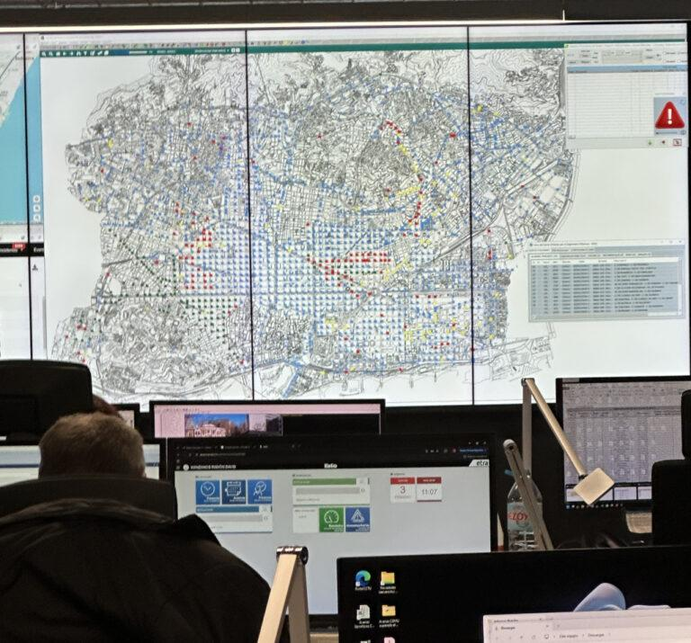
Figure 13: Photograph taken at Barcelona City Council’s Mobility Management Centre.
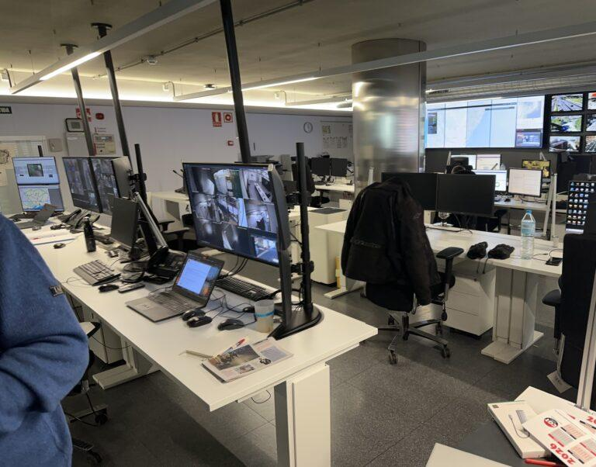
Figure 14: Photograph taken at Barcelona City Council’s Mobility Management Centre.

11. Conclusions
This research project set out to design an adaptive traffic light algorithm based on a mathematical model and to check, by simulation, whether it improves on the traffic lights used today. The phase-pressure model developed in chapter 6 combines two ideas: from queueing theory, the time needed to clear each queue, N/(μ − λ); and, for pedestrians, a pressure that grows with the number of people waiting and with their waiting time, with an extra term that prevents anyone from being forgotten. At every second, the traffic light gives green to the phase with the highest pressure, within minimum and maximum green times.
The review of the first version of the project showed that its code did not implement this model correctly and that its comparison was not fair, so the 80 % improvement it reported was not real. After correcting the code, measuring the capacity of the lanes, calibrating the parameters on separate simulations and comparing against a Webster fixed-time plan and an actuated controller with 20 repetitions per case, the conclusions are:
- The adaptive algorithm works: it serves vehicles and pedestrians safely, adapts its cycle to the demand and never leaves anyone waiting indefinitely.
- It is clearly better than a conventional actuated controller in almost all the situations studied.
- Compared with a well-designed fixed-time plan, it is better when the intersection is saturated or the demand is unbalanced (7–15 % less vehicle delay and more throughput), equivalent with little traffic, and worse at intermediate demand (30–40 %) in an intersection with shared left-turn lanes. The hypothesis is therefore only partially confirmed.
- Its main advantage is for pedestrians: in the simple crossing they wait about a third less without any real cost for vehicles.
The work has also taught me something that goes beyond traffic: a result is only as good as the method used to obtain it. A single simulation, a weak reference or two programs that measure different things can produce very convincing numbers that are simply wrong. Measuring everything in the same way, repeating the experiments and comparing against the best alternative is what makes a result trustworthy, even when it is less spectacular.
Finally, this project is only a first step towards intelligent and coordinated traffic management. The next steps would be to correct the weak point found (estimating how fast each queue is really moving instead of assuming the saturation flow), to take into account the cost of each phase change, and to extend the model to networks of coordinated intersections, possibly with machine-learning techniques. Overall, the project shows that the combination of mathematics, computer simulation and technology can be a key tool for building more efficient, safer and more sustainable cities, as long as the results are tested honestly.

Bibliography
3Cat. (2019, 20 November). Els costos de la congestió per entrar a Barcelona: 63.000 hores i 650.000 euros diaris. https://www.3cat.cat/324/el-costos-de-la-congestio-per-entrar-a-barcelona-63000-hores-i-650000-euros-diaris/noticia/2964709/
3Cat. (2024, 4 July). Trànsit admet que la xarxa viària està al límit: quines són les vies més saturades? https://www.3cat.cat/324/transit-admet-que-la-xarxa-viaria-esta-al-limit-quines-son-les-vies-mes-saturades/noticia/3301784/
Ajuntament de Barcelona. (n.d.). Portal Barcelona Dades. Retrieved 4 March 2026 from https://portaldades.ajuntament.barcelona.cat/ca/estad%C3%ADstiques/akyttjn8ff
Ajuntament de Barcelona. (n.d.). Seguretat viària. Retrieved 4 March 2026 from https://ajuntament.barcelona.cat/guardiaurbana/ca/seguretat-viaria
Alcolea, A. (2025, 10 March). TomTom ha estudiado a las ciudades con los peores atascos y en España hay un sorprendente nombre propio: Valencia. Xataka. https://www.xataka.com/movilidad/tomtom-ha-estudiado-a-ciudades-peores-atascos-espana-hay-sorprendente-nombre-propio-valencia
Ara. (2022, 20 April). Colau haurà eliminat 17 carrils de trànsit a l’Eixample el 2023. https://www.ara.cat/societat/barcelona/colau-haura-eliminat-17-carrils-transit-l-eixample-2023_1_4344588.html
Ara. (2023, 19 April). Barcelona està més col·lapsada de trànsit segons 8 de cada 10 conductors. https://www.ara.cat/societat/barcelona/barcelona-mes-col-lapsada-transit-segons-8-10-conductors_1_4680071.html
Barcelona Metròpolis. (2021, 30 September). Com ens movem. https://www.barcelona.cat/metropolis/ca/continguts/com-ens-movem
betevé. (2022, 11 July). L’Eixample concentra un de cada tres accidents amb ferits de tot Barcelona: 1.115 només fins al juny. https://beteve.cat/mobilitat/eixample-concentra-1-cada-3-accidents-barcelona-2022/
Diario Público. (2023, 24 April). El trànsit de cotxes als accessos de Barcelona baixa un 11% en vuit anys. https://www.publico.es/public/transit-cotxes-als-accessos-barcelona-baixa-11-vuit-anys.html
DLR. (n.d.). SUMO documentation. Retrieved 4 March 2026 from https://sumo.dlr.de/docs/index.html
El Nacional. (2022, 25 October). La congestió del trànsit a Barcelona, entre les cinc grans inquietuds dels ciutadans. https://www.elnacional.cat/ca/barcelona/la-congestio-del-transit-trafic-a-barcelona-entre-les-cinc-grans-inquietuds-dels-ciutadans_905967_102.html
El Periódico. (2025, 20 January). Barcelona lidera el rànquing espanyol de temps perdut en embussos: 41 hores a l’any. https://www.elperiodico.cat/ca/barcelona/20250120/barcelona-tiempo-perdido-atascos-informe-2024-113548173
Emanuel, D., Zagoury, A., & Hassidim, A. (n.d.). Green Light. Google Research. Retrieved 4 March 2026 from https://sites.research.google/gr/greenlight
FAMA. (2024, 19 September). La guía definitiva sobre los tipos de señales de tráfico modernas. Ledtrafficlight.cn. https://www.ledtrafficlight.cn/es/the-guide-to-modern-traffic-signal-types
Google. (2023, 10 October). Project Green Light’s work to reduce urban emissions using AI. https://blog.google/outreach-initiatives/sustainability/google-ai-reduce-greenhouse-emissions-project-greenlight
Google. (2024, 29 July). How Google uses AI to reduce stop-and-go traffic on your route — and fight fuel emissions. https://blog.google/outreach-initiatives/sustainability/google-ai-project-greenlight
Institut Ostrom Catalunya. (2023, 19 September). El peatge urbà de congestió: Anàlisi i recomanacions per a reduir la congestió del trànsit i la pol·lució de l’aire a Barcelona. https://www.institutostrom.org/2023/09/19/el-peatge-urba-de-congestio-analisi-i-recomanacions-per-a-reduir-la-congestio-del-transit-i-la-pollucio-de-laire-a-barcelona/
Kleinrock, L. (1975). Queueing Systems, Volume 1: Theory. Wiley.
López, P. A., Behrisch, M., Bieker-Walz, L., Erdmann, J., Flötteröd, Y.-P., Hilbrich, R., Lücken, L., Rummel, J., Wagner, P., & Wießner, E. (2018). Microscopic traffic simulation using SUMO. 21st IEEE International Conference on Intelligent Transportation Systems (ITSC), 2575–2582.
Nació. (2022, 5 April). Congestió a Glòries: un embut històric que el túnel no ha solucionat. https://naciodigital.cat/societat/congestio-a-glories-un-embut-historic-que-el-tunel-no-ha-solucionat.html
TomTom. (n.d.). TomTom Traffic Index. Retrieved 4 March 2026 from https://www.tomtom.com/traffic-index/about/
Transportation Research Board. (2022). Highway Capacity Manual (7th ed.). The National Academies Press.
Varaiya, P. (2013). Max pressure control of a network of signalized intersections. Transportation Research Part C: Emerging Technologies, 36, 177–195.
Webster, F. V. (1958). Traffic Signal Settings (Road Research Technical Paper No. 39). Her Majesty’s Stationery Office, London.

Annexes
The annexes are published in the project repository, https://github.com/manexstako/Adaptive-traffic-signal-control, so that every result can be reproduced.
Annex | Contents | Location in the repository
1. SUMO files | Networks and route files of both intersections | simulation/scenarios/
2. Python code | Adaptive controller, baselines, experiment runner, analysis and unit tests | simulation/atsc/, simulation/*.py, simulation/tests/
3. Simulation results | Every individual simulation (one JSON line each), parameter-tuning runs, saturation-flow measurement | simulation/results/runs.jsonl, tuning.jsonl, saturation_flow.json
4. Calculations | Means, confidence intervals, paired improvements and figures | simulation/results/summary.csv, comparison.json, figures/
5. Original version | The original Catalan thesis, code and results, unchanged | Catalan/

Declaration on the use of generative AI tools
Original version. Within this research project, large language models (LLMs) were used as tools for technical and methodological support, under the direct supervision of the author. The tools used were Claude (Anthropic), ChatGPT (OpenAI) and Gemini (Google). Claude was used to generate the base structure of the Python code, especially the integration with SUMO’s TraCI module; ChatGPT for debugging and optimising specific code fragments; Gemini to speed up the consultation of SUMO’s technical documentation and to cross-check data on Barcelona’s road infrastructure, whose sources were later verified manually. Text-processing capabilities were also used to polish the academic register of some sections.
English edition (2026). For this edition, Claude (Anthropic), used through Claude Code, was used to translate the text into English and as support in reviewing and optimising the simulation code and the mathematical formulation, in running and analysing the simulations, and in drafting the text that presents the new results. This work was carried out under the supervision of the author, who is responsible for the final content.
Authorship. The original idea of the adaptive algorithm, the phase-pressure formulation, the design of the simulation scenarios and the visit to the Mobility Management Centre are the author’s own work. The refinements of the model in this edition keep the author’s formulation and derivation.

